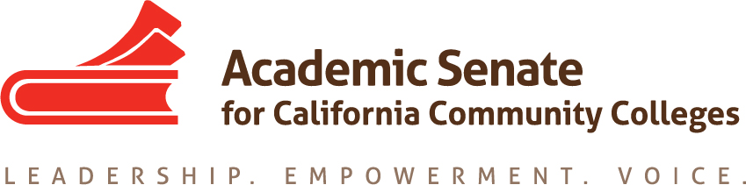

NONCREDIT COMMITTEE

Monday, April 23, 2018

1:00-2:00

Zoom

(See end of agenda for Zoom teleconference information)

AGENDA

Present: Randy Beach, Ginni May, Curtis Martin, Donna Necke, Bernie Rodriguez, Jan Young
Absent:

- Call to Order, selection of note taker

- Spring committee meeting calendar
  - Spring online meetings – Monday, May 14 at 1:00??? for conference debrief?

- Conference Details – Career and Noncredit Education Institute, May 3-5, Costa Mesa.

- Updates
  - Chancellor’s Office Update (Chantee Guiney)
  - 5C Update (Randy Beach and Ginni May)
  - ACCE Update (Jan Young)

- Committee Priorities for 2017-2018 – See committee priorities spreadsheet
  - Assigned resolutions – 13.02 F15, 9.07 S16, 16.02 F16, 7.03 S17, 7.04 F17
  - Strong Workforce Task Force Recommendations – 10(b), 12(b)

- Noncredit Curriculum Streamlining Work Group

- Noncredit Paper revision – update.

- On the Horizon
  - Identification and discussion of issues for future discussion

- Announcements
  - Next meetings – May 14???
  - Spring Regional Meetings - Click here for more information.
  - Faculty Leadership Institute – June 14-16, location TBD
  - Curriculum Institute – July 11-14, Riverside Convention Center
  - Part-time Faculty Institute – August 2-4, SFO Westin, Millbrae

Zoom Call-in/Login Information
Join from PC, Mac, Linux, iOS or Android: https://cccconfer.zoom.us/j/604325414
Or iPhone one-tap (US Toll): +16468769923,604325414# or +16699006833,604325414#

Or Telephone:
Dial:
+1 646 876 9923 (US Toll)
+1 669 900 6833 (US Toll)
+1 408 638 0968 (US Toll)
Meeting ID: 604 325 414
International numbers available: https://zoom.us/u/dx8wHDKgb
Status of Assigned Resolutions and Strong Workforce Recommendations

- In Progress
- 13.02 F15 – In progress. The Chancellor’s Office is working on updating the document “Noncredit at a Glance.” The outline for updating the ASCCC paper “Noncredit Instruction: Opportunity and Challenge” was approved by the Executive Committee in fall 2016. The committee discussed combining the documents at the October 5 meeting. Before proceeding, the committee should review the approved outline to determine if anything needs to be revised.
- 9.07 S16 – In progress. The guidance is being developed by the Chancellor’s Office through 5C.
- 16.02 F16 and 7.03 S17 – In progress. The Chancellor’s Office is reviewing the CCC Apply requirements in consultation with Admissions and Records representatives. There have been concerns expressed about how changing the CCC Apply for noncredit would affect compliance with the legal requirements to collect certain data.
- 7.04 F17 – Assigned.
- Strong Workforce Recommendation 10(b) – In Progress.
- Strong Workforce Recommendation 12(b) - In Progress. This will be addressed through the completion of resolution 13.02 F15 and through the 2018 Career and Noncredit Education Institute.

- Completed

