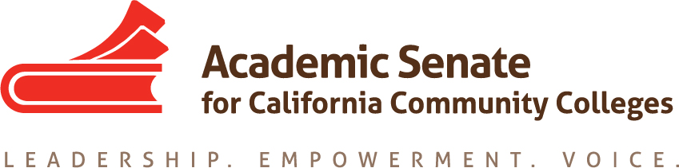

Noncredit Committee

Wednesday August 29th, 2018

4:00 PM – 5:30 PM

Join from PC, Mac, Linux, iOS or Android: https://cccconfer.zoom.us/j/3285687631

Or iPhone one-tap (US Toll): +14086380968,3285687631# or +16468769923,3285687631#

Or Telephone:

Dial:

+1 408 638 0968 (US Toll)

+1 646 876 9923 (US Toll)

Meeting ID: 328 568 7631

- Order of the Agenda
- Welcome and Introductions
- Review of Committee Charter

The Academic Senate Committee on Noncredit will serve as a resource to the President and Executive Committee on issues related to instruction, counseling, student services, and program development in noncredit and the role of faculty in noncredit instruction as related to governance and local participation in academic and professional activities.

- Review of Assigned Resolutions
- AB 705
- Collaborative Institute
- Future Meeting Dates
- Other

