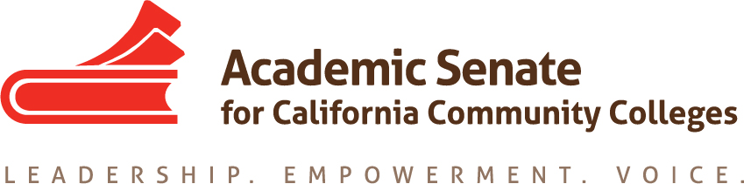

Noncredit Committee

Wednesday August 29th, 2018

4:00 PM – 5:30 PM

Members Present: W. Brill-Wynkoop, G. Dent, S. Oates, L. Parker, C. Rutan, L. Saperston, and J. Young

Meeting called to order at 4:03 PM

- Welcome and Introductions: The committee introduced themselves.

- Review of Committee Charter: The committee reviewed the current charter and there were no recommended revisions.

- Review of Assigned Resolutions: Resolution 13.02 F15 calls for ASCCC to update System Guidance for Noncredit Curriculum. The outline for the revisions was previously approved by the Executive Committee and C. Rutan will send the outline to committee members. Committee members should review the outline and the current version of the paper prior to the next meeting. The goal is for the paper to be drafted by late November/early December for 1st reading by the Executive Committee in January with the intent to bring the paper to the Spring 2019 Plenary Session for adoption. Resolution 9.07 S16 has been partially addressed by the AB 705 FAQ released in August. Best practices for the use of noncredit prerequisites and corequisites will either be included in the paper being developed or will be in a separate white paper. Resolutions 16.02 F16 and 7.04 S17 are related to CCCApply, which is current being revised. Resolution 7.04 F17 is about internship opportunities for noncredit students. C. Rutan may request ask the 5C co-chair for assistance as internships are not clearly defined in Title 5.

- AB 705: The committee was provided with both guidance memos and the frequently asked questions document. There will be a webinar for noncredit and adult education practitioners on September 7 from 12 PM – 1:30 PM about AB 705. There have been questions about the new interpretation about the ability to require noncredit prerequisites and corequisites and how that could impact the alignment of noncredit to credit. The committee will need to support colleges, especially those with limited experience with noncredit, as they explore noncredit options to meet the requirements of AB 705. Committee members may be asked to assist with regional meetings and/or webinars that ASCCC may offer to provide additional support to colleges as they implement AB 705 locally.

- Collaborative Institute: The 2nd Collaborative Institute will be in San Diego on April 25th – 27th and the Noncredit Committee will be working with the CTE Leadership Committee to plan the event. The first draft of the program needs to be reviewed by the Executive Committee at the February 2019 meeting, so the draft needs to be completed by early January. A future meeting for the two committees will be scheduled to begin drafting the program. C. Rutan will send last year’s program to committee members for them to review and think about which sessions should be kept for this year’s institute.
- Future Meeting Dates: The next meeting will be on September 17, 2018 at 4 PM via Zoom.

Meeting adjourned at 4:54 PM.

Respectfully submitted,

Craig Rutan

Approved on September 4, 2018

