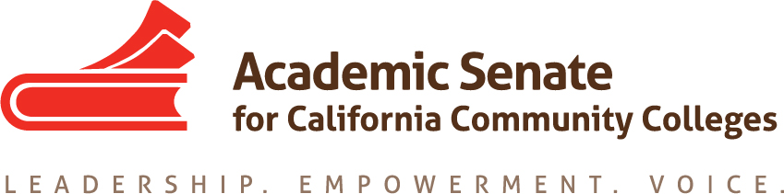

ONLINE EDUCATION COMMITTEE

Thursday, 25 February 2016

11:00 AM – 3:00 PM

Pierce College

Distance Education Building

CCC Confer – 888.450.4821

Passcode: 899634

MINUTES

- Call to Order – 11:05 (by Wheeler on phone)

- Approval of the Agenda – approved
-Members present: Dolores Davison, Wheeler North, Joe Perret, Fabiola Torres, Laurie Vasquez (by phone)
-Guests: Wendy Bass, John Freitas (by phone)

- Discussion items, with action as needed
  - Report out on Instructional Design and Innovations Institute
    - Good responses from attendees
  - Report out on Accreditation Institute breakout on DE and Accreditation
    - Presentation was well attended and should be a focus going forward both at the OE regionals and at plenary
  - Plenary breakout on Hot Topics (probably with Accreditation) – unlikely that any committee members will be able to attend
  - OE Regionals (8 and 9 April)
    - Structure and breakouts/general session – change structure slightly
9:00-10:00 Continental Breakfast and Registration
10-10:45 Welcome, Dolores Davison, Online Education Chair
Update: Online Education Initiative
Introduction of new TRIS VC
10:45-10:55 Break
10:55-11:45 What to Expect When You’re Expecting...the Accreditation Visiting Team
11:50-12:35 Lunch
12:40-1:40 Breakout Session #1
--Accreditation Panel and Follow Up
--Expanding Choices in OE – CTE, labs, noncredit
--Professional Development Online
1:45-2:45 Breakout Session #2
--Accreditation Panel and Follow Up (repeat of session #1)
--Accessibility and OE
--Effective Online Practices
    - Who will be participating? – Dolores, John Freitas, Ginni May, Wheeler, Fabiola at both north and south; Laurie at south

  - Annual Report
    - The Online Education Committee has been actively engaged in assisting faculty in pedagogy and other issues surrounding online education. The OE committee participated in multiple breakouts at the Fall Plenary session as well as the Instructional Design and Innovations Institute, completed the last Rostrum article to complete resolution 11.01 (S12) regarding effective online education practices, and authored several resolutions regarding online education as an academic and professional matter. Most significantly, the OE committee will be hosting a pair on Online Education Regional meetings, to be held 8 and 9 April, to assist faculty and others in the issues that are currently facing colleges, including the Online Education Initiative, textbooks and Open Educational Resources, and curriculum for online courses. – will be submitted by Dolores

  - Best of the Rostrum – Faculty Primacy in Online Ed (September 2015)
  - Laurie reported that concerns about accessibility continue to be significant; she will forward the message that former Chancellor Scott sent out and will ask that the ASCCC discuss ways to work with that

- Announcements
a. Area Meetings, 1 (Areas A and B) and 2 April (Areas C and D)
b. Online Education, 8 April (College of San Mateo) and 9 April (Glendale)
c. Noncredit Regionals, 15 April (San Joaquin Delta) and 16 April (Mt. SAC)
d. Spring Plenary, 21-23 April (Sacramento)
e. CTE Leadership, 6-7 May (Anaheim)
f. Faculty Leadership, 9-11 June (Riverside)
g. Curriculum Institute, 7-9 July (Anaheim)

- Adjournment

