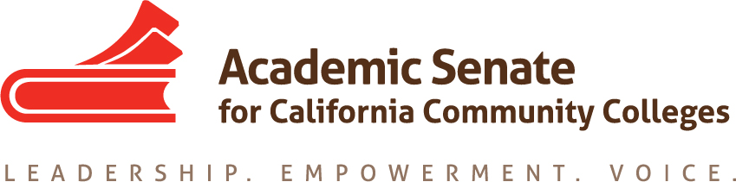

ONLINE EDUCATION COMMITTEE

Wednesday, August 26, 2015

10:00 AM – 3:00 PM

Glendale College, Administration Room AD121

1500 N. Verdugo Avenue, Glendale, CA

CCC Confer: 1-888-450-4821

Participant Passcode: 141703

http://www.cccconfer.org

AGENDA

- Call to Order – 10.25am

- Introductions and Note Taker: Wheeler North
Everybody introduced themselves, Dolores Davison (chair), Fabiola Torres, Sanya Soyemi, Joseph Perret, Laurie Vasquez (by phone for the afternoon portion of the meeting).
Gennean Bolan tried to call in but was not successful

- Approval of the Agenda
Approved

- Set meeting times for remainder of year
Sep 30 - 1400, Oct 30 – 0900, Jan 11 – 0800, one hour each on CCCConfer; will set in person meeting for early February depending on acceptance of Online Ed regionals

- Priorities for 2015-16
  - Outstanding resolutions from last year
There currently are no resolutions from prior years but there are activities the committee needs to work on.
  - Role of ASCCC and Online Ed committee with PD organizations (@One, OEI, etc)
The discussion started around some of the changes occurring with OEI now hiring a dean to oversee the professional development arm of OEI (via Foothill/De Anza’s hiring processes.)
  - Curriculum Regional Participation
These will be Nov 13/14th Online Ed will likely be helping out
  - Online Education Regionals (spring?)
Dolores will be submitting a request to ASCCC Exec to consider having N/S regional one-day events.
  - Innovations Institute Participation - Breakout ideas relative to the Innovations Institute – engaging in the online world across generations, keeping relevant, inspiring engagement across the shifting culture, technology influence on culture, on professional development, etc. regarding online education
  - Rostrum articles
Dolores described the parameters and expectations around Rostrum articles.

    - Compressed calendars as they affect distance education and apportionment.
    - Student preparation and readiness
    - Senate involvement in online education: How do you check for regular and effective contact/best practices
    - Upcoming Rostrum may have two articles (Online education and faculty primacy, by Dolores and Fabiola, and Online Education and Accessibility, by Laurie and Dolores)
    - Please suggest any other ideas.

- Plenary activities
  - Breakout topics – Sep 7th to submit topics:
    - Hot topics in Online Education (could included best practices for regular and effective contact, involvement of senates in choosing a CMS, need for faculty voice in OE decisions, etc.)
    - OEI Updates from the faculty participants (not the management team)
    - Accreditation and Online Education: What to expect from the evaluation team (check with Randy regarding cross-listing this; also an option for AI)
  - New Resolutions?
    - Accessibility
    - Faculty Primacy – Potentially need a stronger position on faculty primacy with respect to decisions that are made about online education. Faculty participation in decision-making is difficult in regards to leadership often being from the ranks of faculty who are no longer faculty having moved into administration.
    - Others
SARA – State Authorization of Reciprocity Agreement bill is on a two-year cycle.
Local definition of hybrid – must be faculty driven. Potential resolution about removing the really stupid Ed Code 51% reporting requirement.

- Upcoming Events
  - ASCCC Area meetings October 23 and 24, locations vary. Contact your area representatives.
  - ASCCC Fall Plenary Session, November 5-7, Irvine Marriott Hotel.
  - Curriculum Regionals, November 13-14, locations TBD.

- Information from committee
There was some general discussion about concerns from the field and concerns about the trends in online efforts that focused on ensuring faculty purview in decision-making at the local level and within some of current statewide projects going on.

- Adjournment - 1420

