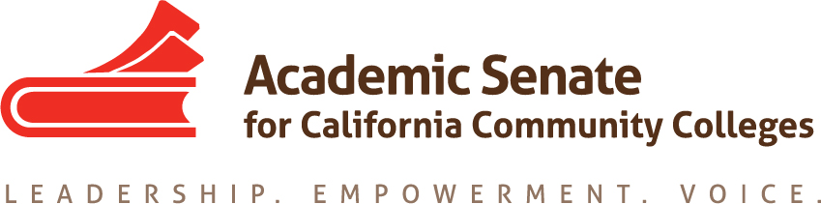

Online Education Committee

Zoom meeting

October 3, 2018

11:00am to 12:00pm

MINUTES

In attendance: Anna Bruzzese, Geoffrey Dyer, Leticia Hector, Michael Heumann, Julie Oliver
Absent: Cathy Fernandez

- Welcome
At 11 am Geoffrey Dyer (chair) welcomed the committee members participating in today’s meeting.

- Status of Previous Action Items

  - 9.03 S18 Effective Practices in Online Communication Courses
Leticia suggested some changes to the survey. The ASCCC Executive Committee reviewed and approved the survey at their last meeting on September 29. The ASCCC staff prepared it for posting using Survey Monkey, and they have requested committee’s approval of the survey description. After a brief discussion, the committee approved the following description:

“Resolution 9.03 S18 directs the Academic Senate for California Community Colleges to disseminate effective and promising practices for teaching oral communication courses online. The following survey of communication faculty is designed to collect information from discipline experts regarding speech presentations before a live audience, in the fully online modality, and to provide discipline experts the opportunity to report practices which they deem to be effective or promising in online communication courses.
Please complete the survey by October 24, 2018.”

  - 9.04 S18 Effective Practices in Online Lab Science Courses
Julie sent a draft survey to everyone last night. The committee discussed the need for this survey, as well as the wording of proposed questions. The committee agreed that there is still a need for the survey. The deadline to get this survey onto the next ASCCC Executive Committee’s agenda is October 11. Julie will send out a revised survey for feedback shortly. The committee also discussed having a deliverable by Spring Plenary, 2019, either in the form of a Rostrum article or a breakout at the Spring Plenary, depending on the survey results.

  - 11.01 S17 Using Savings from Adopting Canvas
Michael had volunteered to write a Rostrum article on this topic. There was a discussion about the focus of this article and the committee agreed that it may be useful if the
focus is on how colleges used the money from savings resulting from adopting Canvas. Michael will look into it. The Rostrum article submission deadlines are January 7 and March 4.

- Plenary Planning
Geoffrey reminded the committee that the list of presenters and descriptions are due to the ASCCC Executive Committee by October 6. Below are the Online Education-related breakouts and presenters:
    - The California Online Community College (Geoffrey, Julie, Craig Rutan)
    - Regular and Substantive Contact in Oral Communication and Laboratory Science (Geoffrey, Julie, Anna)
    - Hot Topics in Online Education - Including Single Cloud Based Library Services Platform (LSP) (Anna, Doug Achterman, Amy Beadle, Conan McKay, Dan Crump)
    - CVC-OEI-C-ID: The Intersection of Initiatives (Anna, Julie, Michelle Pilati, Kate Jordahl)
- Pre-Session Resolutions
The ASCCC Executive Committee reviewed 17 pre-session resolutions and decided which ones are going forward. Both of ours got approved:
  - Academic Senate for California Online Community College
  - Local Adoption of CVC – OEI Course Design Rubric; there was a change to that one to encourage local college to adopt (rather than consider adopting) the CVC – OEI Course Design Rubric.

- CVC-OEI One-Time Grant Funding in California Budget –
The committee discussed the recently BOG-approved $35 million in competitive grant funding and reviewed the objectives associated with it.

- November Meeting
The committee tentatively agreed to meet on Wednesday, November 7 at 11 am. Geoffrey will check with Cathy to see if this time works for her.

- Announcements
  - Events

The committee meeting adjourned at 12 pm.

Minutes respectfully submitted by Anna Bruzzese.

