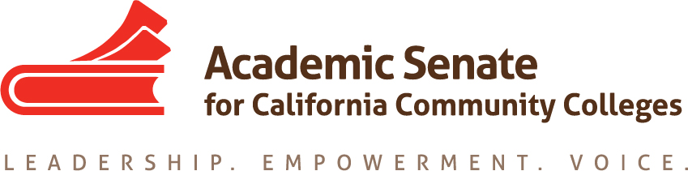

Part-time Committee
Thursday, May 20, 2021
2:30 p.m.—4:00 p.m.

Zoom Meeting
Join from PC, Mac, Linux, iOS or Android: https://cccconfer.zoom.us/j/95061207497
Telephone Dial: +1 669 900 6833 (US Toll)
Meeting ID: 950 6120 7497

AGENDA
The part-time faculty committee provides recommendations to the Executive committee on academic and professional matters that affect part-time faculty members. The committee recognizes that part-time faculty make up the majority of California community college faculty and serve disproportionately-impacted students. This committee advocates for diverse part-time faculty colleagues, ensuring their access to professional and leadership development offerings as well as shared governance opportunities at the local and statewide levels. The part-time faculty committee collaborates with the executive committee to develop and provide opportunities where part-time faculty gain additional insight on issues germane to academic and professional needs. This committee is also focused on promoting diversity within part-time faculty pools with the goal of having educators who reflect the student population, and this committee further commits to empowering part-time faculty voices who have been historically excluded (e.g., colleagues of color).

- Members Roll Call:

Michelle Bean—Chair | Grace Chee | Alpha Lewis
Karen Chow—2nd Chair | Chelsea Hull | Luis Zanartu
Steven Chang | Theodore Kagan

- Call to Order and Agenda Adoption
  - Community norms: empathy, communication, responsibility
  - Google Shared Folder

- Minutes
  - Volunteer
  - March summary and May summary in email

- Shout Outs, Affirmations, and Lean-in

- Plenary
  - Final Resolutions Packet
    - Resolutions of note: Ethnic Studies, Chosen name for students and faculty, OER antiracism work, AAPI no hate, students on hiring committees, part-time faculty paper
  - Spring Plenary—34 part-time faculty attended
  - ASCCC Officer Elections
    - Results
    - Part-time colleague Anastasia Zavodny ran for south representative

- Committee Goals and Priorities
  - PTC work plan
  - Survey Results from Part-time Institute
  - Mentor Handbook approved

- Part-time Faculty Spring Nexus Workshops
  - Google unofficial listserv update (Chelsea)
  - Nexus Website
    - FAQs Section Still Needed—click here to please add questions and answers
  - Nexus Workshops Survey Data
    - Pre Survey
    - Exit Survey

- End of the Year Report
- Need feedback—click here to make comments using the +plus sign in the toolbar

- Announcements
  - Forward Application for Statewide Service to peers—selecting members now for 2021-2022!
  - Sign up for ASCCC listservs—part-time listserv available
  - Check for ASCCC upcoming events at here
  - ASCCC Foundation Innovation Scholarship for professional development opportunities
  - Legislation to watch: AB 375 and AB 1269

- Next meeting: Today is last meeting—thank you!

- Closing Comments--any other final comments or suggestions?

- Adjournment

Completed Tasks:
- Mentor Handbook
- Nexus Website
- Nexus Workshops
- Rostrum article: PT Voting Rights
- Rostrum article: PT Paths of Employment
- Part-time Google Listserv
- Part-time Institute
- Rostrum article: Mentoring Programs
- Resolution Fall 2020 1.02: Develop a Resource to Communicate and Encourage Part-time Faculty Leadership
- Plenary sessions: Mentoring Programs and Hiring Principles Canvas Tool
- Rostrum article: Faculty recommendations to second level interviews—focusing on diversifying the faculty
- ASCCC President Special Plenary Invitation Email (on 9/29/20 to local senate presidents and part-time listserv)
- PTC Workplan and Goals
- Updated ASCCC Part-time Committee Charge

