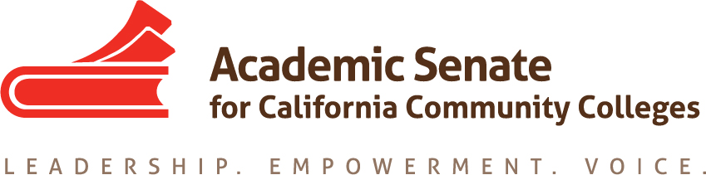

Standards & Practices Committee

3/25/19

4:30 pm – 5:20 pm

ZOOM

Summary

- Call to Order and Selection of Note Taker
Present: Rebecca Eikey, Erik Reese, Kim Perigo, Jorge Ochoa

- Approval of Meeting Summaries
  - February 25, 2019
- Status of Committee Priorities for 2018-2019

- Awards
  - Diversity Award. Winner: Peter Fulks for the Cerro Coso College 's Incarcerated Student Education Program.
  - Hayward Award Reading Process
Recommendation: Continue to redact identifying information from applications. Use same rubric for both full-time and part-time faculty applicants. Separate out the reviewing of the part-time applicants from the full-time applicants. S&P committee members will review all applicants. Area Reviewers will review full-time faculty who are not from their Area. All Area Reviewers will review part-time applicants.

c. Awards Handbook https://asccc.org/sites/default/files/Awards_Handbook_Adopted_8.11.2017.pdf
Revision: https://docs.google.com/document/d/1L8eZVzGoe1dwAoZsOKLn0UcR9aOUAPa2jqxuhGKxjN4/edit

- Policy Renumbering
https://docs.google.com/document/d/1vVymCfT4RwuQYvzmnKv5h3vGtF9D8MOQDyuqTCYkTD0/edit?usp=sharing

- Frequency of Surveys & Disseminating Information Draft Policy.
May 2018 ASCCC Executive Committee Meeting Request: The Standards and Practices Committee to bring recommendations in the fall to the Executive Committee about the survey creation process and analysis and dissemination of the results.”
https://docs.google.com/document/d/1B5ImAshYDbQ14NFrKY4AGEa-wvXX_38bg1YYXsPqtto/edit?usp=sharing

- Equivalency Regional Meetings for Spring 2019
  - Workshops similar to 2017 Curriculum Streamlining
  - Desired outcomes:
      - to promote and improve the use of Equivalencies in the state – provide teams with effective equivalency practices and to examine their own practices for possible improvements
      - to promote use of CTE MQ&E Toolkit
      - write rostrum article

- S&P Meeting Date
    - April 22nd, 4:30 pm

- Adjournment

Committee Charge
The Standards & Practices Committee is charged with reviewing, acting on, and monitoring various activities as needed and assigned by the President or the Executive Committee of the Academic Senate. The Standards & Practices Committee's activities include, but are not limited to, conducting Disciplines List hearings, monitoring compliance with the Full Time/Part Time Ratio (75/25 rule), reviewing the faculty role in accreditation, screening faculty Board of Governors applications, analyzing and reviewing suggested changes in Executive Committee policies and Senate Bylaws and Rules, and administering designated awards presented by the Academic Senate. As assigned by the President or Executive Committee, the committee chair or designee will assist local academic senates with compliance issues associated with state statutes and their implementation.

