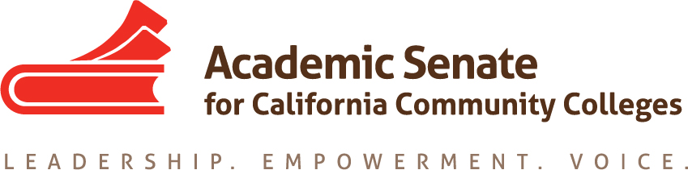

Standards & Practices Committee

November 25, 2019

6:30p.m.—8:00p.m.

Zoom: Join from PC, Mac, Linux, iOS or Android: https://cccconfer.zoom.us/j/671823052

Or iPhone one-tap (US Toll): +16699006833,671823052# or +16468769923,671823052#

Or Telephone:

Dial:

+1 669 900 6833 (US Toll)

+1 646 876 9923 (US Toll)

Meeting ID: 671 823 052

International numbers available: https://cccconfer.zoom.us/u/adWsU2CQ5G

Or Skype for Business (Lync):

SIP:671823052@lync.zoom.us

AGENDA

- Welcome

- Updated ASCCC Bylaws and Rules

- Status of Disciplines List Revisions Submissions

- Awards
  - Exemplary Program
  - Hayward
  - Regina Stanback-Stroud Diversity Award

- The Second Minimum Qualification

- CTE MQ Toolkit
  - Resolution 19.01 F19
  - Request from CTE Leadership Committee:
    - Outline for Webinars

- Face-to-face Meeting: February 18
  - Travel Request
  - Reimbursement Request Form
  - Planning

- Scheduling of Upcoming Meetings
    - December 16 at 6:30p.m. Zoom
    - January 27 at 6:30—8:00 p.m. Zoom
    - February 18 at Mission College in Sylmar.
    - March 23 at 6:30—8:00 p.m. Zoom
    - April 20 at 6:30—8:00 p.m. Zoom

- Committee Priorities from Adopted Resolutions
  - 17.09 Fall 17—ensuring MQs for apprenticeship in Disciplines List has been addressed, but other Resolveds have not been.
  - 10.01 Spring 18—calling for taskforce to review that all disciplines are updated and current.
  - 19.03 Spring 18–oppose efforts to permit single course equivalency.

