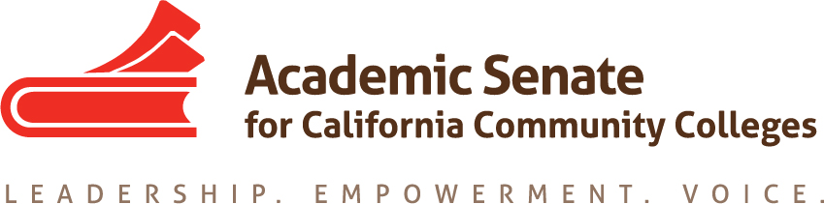

Standards & Practices Committee

8/20/18

3:00 pm – 3:45 pm

SUMMARY

- Members Present: Rebecca Eikey, Cheryl Aschenbach, Erik Reese, Kim Perigo, Adrienne Foster; Members Absent: Jorge Ochoa, Michael Berke
- Welcome & Introductions – introductions were made.
- Meeting Calendar – Committee would like to set up regular meeting dates. A doodle poll will be sent.

- Review of the Committee Charge and Responsibilities - Committee Charge was reviewed.

- Awards (See Awards Handbook)
  - Exemplary Program Award Theme – The theme for this award was by the ASCCC Executive Committee to be Environmental Responsibility (based on a Resolution F17 13.02). The committee will provide help regarding the language to be used in the letter sent out for applications for this award. There was concern about making sure the language is broad enough to allow for a diversity of programs (urban vs rural, etc). The committee members will contribute via Google Docs to the editing of the letter for this award.

  - Hayward Award - The committee discussed the change in the Hayward Award from being based on areas to statewide. There was concern from last year’s committee regarding the rubric used to evaluate applicants. There was rubric change in 2013, but not since then. The committee discussed the particular sections of the rubric that could be more challenging to evaluate (such as b, c and e). Historical data was shared regarding the use of the rubrics and applicants. However, it was not clear from the aggregate of the data what the issues are with the current rubric. Thus, the committee decided to keep status quo with the intention of re-evaluating the rubric after the 2017-18 round of Hayward Award applicants are reviewed.

- Status of Committee Priorities for 2018-2019 – there was a brief update related to the work of the Committee with regards to the assigned resolutions and additional taskforces related to the Strong Workforce Recommendations. Additional work of the committee this year may include responding to Executive Committee meeting requests, such as reevaluating Mission & Value Statement, revising Policy 40.00 (Honoring Faculty Leaders), Election Rules & Processes, and how surveys and related information is disseminated.

- Fall Plenary Planning – not discussed.

