The ASCCC Guided Pathways Task Force created a survey to identify specific information and tools to support academic senates through the design and implementation of a guided pathways framework.
Executive Summary
Rich data were collected from a survey sent to local academic senate presidents Spring 2018 about college engagement with guided pathways (GP). Overall, the data clearly show that colleges are engaged and faculty in most colleges are either leading or collaboratively guiding the work. There is still confusion about the various guided pathways programs, including the actual work of guided pathways such as how it is different from CTE pathways and first year experience. The survey clearly indicated areas of challenge and places that ASCCC can help the colleges in their implementation process. A list of benefits and potential negative outcomes provide great opportunity for training and resources to help colleges move in a positive direction. The need for models from other colleges, requests for clarity on verbiage and specific strategies indicated potential for regional visits, online resources and webinars. Numerous comments about addressing a collaborative and institution-wide vision indicate the importance of local.
Responses:
There were 87 responses from 70 different colleges. Initially 62 colleges responded by March 30, but the survey was re-sent to colleges and closed again on April 30 to create additional opportunity. 61% of CCCs responded with a broad representation of small and large, rural and urban, multi-college and single college districts, and all regions. Data were aligned to remove multiple responses form colleges but all responses were saved. Because this was sent to local senate presidents, when duplicated by a college, submissions from non-presidents were removed from the count, but all comments were saved for the college.
Observations:
Guided Pathways Program Engagement
The first questions focused on aspects of engagement with guided pathways. 62% of responding colleges have a guided pathway liaison (34.2% didn’t and 4% unsure). Guided pathway liaisons are appointed by local senates to be the point person for activities, information, and contact concerning efforts at their college. The liaisons will be invited to special training and trained to collect information, determine needs, use data and be a conduit for key capacity building at each college. 77% (54 colleges) responded that they were part of the Guided Pathways Award Program, 39% (27 colleges) indicated they were part of California Guided Pathways and 6% (4 colleges) AACC Guided Pathways. 10% (7) indicated unsure and 12% (8) no guided pathways program.
There is still confusion among colleges regarding guided pathways work and programs. Because 100%, all 114 colleges submitted a self-assessment and qualify for the CCCCO award, as compared to the 64% affirming they are participating and 15 colleges (22%) indicating they are unsure or participating no guided pathways programs. The survey responses represent 61% of the California Community Colleges yet 27 colleges thought they were in the CA GP Program; a program that has only 20 participants.
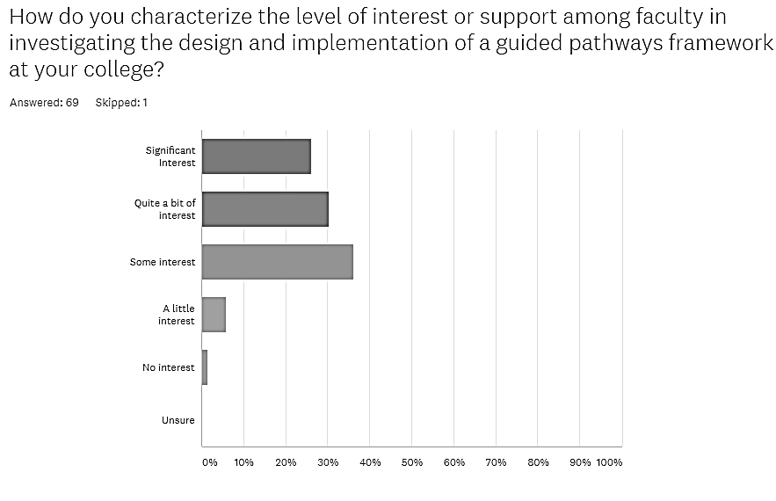
Faculty interest or support represented 98.6% of the responses with only one college reporting no interest at this time and only 4 colleges reporting “a little interest.”
How do you characterize the level of interest or support among faculty in investigating the design and implementation of a guided pathways framework at your college?
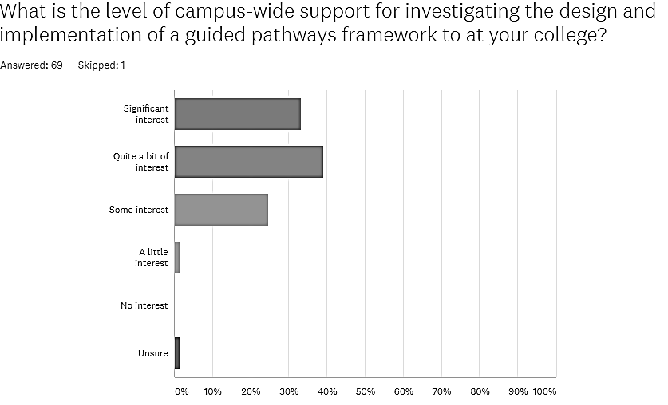
The level of campus-wide support for investigating design and implementation of guided pathways was very high with 72.5% reporting “quite a bit” or “significant” interest and 97% of colleges indicating some to significant interest. No college reported “no interest” and only one college was “unsure.”
A consideration of faculty and college-wide support as reported by senate presidents in Spring 2018 would indicate a high level of interest and potential engagement among the faculty as well as college-wide.
Data Access
Most senate presidents (73.5%) reported that they had adequate data and resources to interpret the data related to guided pathways.18 Colleges (26.5%) felt they did not have adequate data resources or were unsure.
Comments indicated that many resources are available but not easy to find. Other comments indicated a need for data literacy and difficulty with centralized resources and inadequate human resources for the data discussions. One comment indicated a need for multi-level assessment to reflect the reality of student success and pathways.
Faculty Driven Processes
The majority of respondents (68.9%) felt that the process was faculty driven. However, colleges responding negatively (31.1%) to this had strong comments about the process being driven by administration and lack of opportunity to contribute or be heard. Overall, the comments indicate that a rough start may have been followed by faculty commitment. Some show strong faculty leadership where the senate president is co-chairing with the college president. Some comments indicated that guided pathways is a standing agenda item and another that a senate resolution was driving implementation.
- 7 colleges clearly indicated strongly driven by administration.
- 14 responses indicated the initial start was rocky with improvement and inclusion of faculty beginning to have some positive results.
- 16 responses indicated good collaboration was occurring.
- 15 responses indicated a strong faculty driven process.
Below are a few comments that represent common threads.
The Task Force dealing with Guided Pathway has numerous faculty participants who have provided significant input to the plan.
Faculty might have a good representation on the Guided Pathways Steering Committee, but it is lead primarily upon Administration.
The decision to create a guided pathways framework and apply for the CCCCO guided pathways award was driven by administration. However, in recent months, the development of Guided Pathways has been faculty driven with a lot of representation from classified staff. We are currently recruiting students.
We have ensured this by making every step towards the GP framework subject to Senate approval. Additionally, as Senate President, I co-chair the GP Steering Committee which has a majority of faculty on the committee.
Unfortunately the initial process on our campus was not faculty driven via our Academic Senate at all. However, as faculty gained more information about how to best approach Guided Pathways from the IEPI workshops, our Academic Senate has become strongly involved - this genuine interest and faculty involvement in Guided Pathways has met with significant resistance form our Administration, particularly the College President. It would appear that the plan to approach Guided Pathways by Administration at our college was to simply re-purpose existing frameworks and call them Guided Pathways.
Efforts are spear-headed by a team that includes a Transfer/GE faculty, a CTE faculty, a Basic Skills faculty, and Counselors. The team works closely with the CIO.
We are making a worthwhile effort to inform and involve as many faculty members as possible, gathering support for these cross-functional teams to help implement the activities of the Guided Pathways plan. It is a standing item in EPPIC, which is in a direct contact with Senate, and should be on the standing item on the Senate agenda as well.
Our local Senate appointed an ASCCC Guided Pathways Liaison to strengthen the communication and leadership in investigating the design and implementation of a guided pathways framework. Many faculty still have concerns about this framework. We created a Guided Pathways Task Force to work on the Guided Pathways Plan and engage in more dialogues. This task force includes administrators, faculty from both Academic Affairs and Student Development Divisions. However, we had difficulty getting classified staff and student appointments. But we're now in the process of vetting this draft through the governance process including Classified Senate and Associated Students so all constituent groups are informed about this plan.
Only 63 colleges responded to question 9 concerning sufficient voice in the process. The results were very different. Colleges with good governance structure indicated regular and transparent decision making and other colleges complained that too many decisions were made in cabinet or usurped by administrative efforts. Some colleges that began with a rocky implementation indicated improving collegiality.
Question 9. Do you feel that you have sufficient voice in the process through the shared governance as you begin to discuss a guided pathways framework?
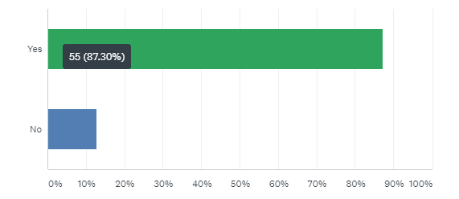

Respondents commented that the academic senate was involved or trying to get more faculty involved and several colleges commented that support(?) of the college president was important to the process. Many felt that they had documented a way forward and that local voice and shared governance were important to implementing the plan.

Question 10 sought to identify successes or effective practices thus far. There were 55 responses to this question indicating that most respondents can chart some success.

Successful Practices so far…

Successful practices implemented this far and identified by the senate presidents include mapping pathways, onboarding practices, establishing an implementation team, scheduling practices, locating the effort in equity, early alert practices, acceleration for basic skills courses, multiple measures for assessment, effective communication, establishing meta-majors, and creating retention specialists positions.

Question 11 asked,” What have been your college’s biggest challenges in the design and/or implementation of guided pathways frameworks, so far?”

Biggest Challenges | Number Responses
No institution-wide vision or momentum | 9
Time and other resources | 7
Forcing course, program or student limitations | 7
Communicating the GP basics broadly | 7
Difficulty with administration | 6
Resistant faculty | 3
Knowing where to start | 3
AB 705 Implementation and confusion with additional initiatives | 3
Meta-majors and program mapping | 3
Inability to get constituencies to genuinely engage with senate | 2
Technology issues including getting IT onboard or other | 2
Initiative fatigue | 2
Student involvement | 2
Leadership | 2
Faculty Appointment to GP leadership | 1
Statewide website vague | 1
Math | 1
Funding for institutionalization | 1
Dealing with planning prior to an official committee | 1

Comments:
“Trying to adjust to the changes necessitated by AB 705 as we work on the guided pathways.”
“There has been resistance or misunderstanding from some faculty who feel that "they already do GP," or feel that it is just another state initiative, for example.”
“Our college’s biggest challenge in the design and/or implementation of guided pathways frameworks has been our inability to engage in genuine collaboration in this endeavor. The Academic Senate meetings and leadership have attempts multiple times in many venues to reach out to all constituencies and work transparently and collaboratively but this has not been reciprocated by our colleagues, most notably and significantly by the Administration.”
“We still need to develop a ‘second-year’ plan for our students. Developing faculty mentorships and program mapping are great starts, but so much of our attention these past five years has been first-year focused. Also, we need to get more input with adjunct faculty and students. When it is explained, this initiative is well supported, more than the other initiatives because of its student-centered focus. But it has still been introduced in groups. Opening this to the whole campus at one time is more challenging. We haven’t had one big campus meeting on this yet, to invite more faculty and especially students.”
Getting off the ground with competition from all the other issues facing the college: implementation of a traditional dean structure, accreditation, a new ERP, new curriculum system, AB705, dual enrollment, etc.” etc. etc.
“Informing people what it is, it's a big learning curve. It is exacerbated by this being a rural district.”

Potential Positive or Negative impacts from a Guided Pathways Framework Question 12 Best quote from this question “Change is hard…”
Potential Positive Effects | Potential Negative Effects
Potential Positive Effects on Institutions | Potential Negative Effects on Institutions
GP Framework allows student-oriented transformation | May fail to integrate important projects and initiatives
Great conversations; requiring greater and effective communication | Conflicts requiring mediation and compromise
Greater transparency and clarity | Fiercely guarded territory = tensions
Better faculty become mentors concerning jobs and transfer clarity on GE may be more fruitful for students and faculty | Loss of faculty autonomy; increased faculty competition for courses
Increase completions & decrease unnecessary units; Address completion and success rates | Performance –based goals may narrow student success focus
Profoundly transformational | Dysfunctional college no agreement on plan
Institution-wide collaboration; constant and deliberate collaboration | Marginalizing smaller departments without adequate representation
Potential Benefits to Students | Potential Negative Effects on Students
Closes equity gaps | Treating students as a number
Increased retention and persistence | Eliminate exploration; Destroying personal enrichment/liberal arts
Clear navigation for students | Loss of specific courses as evidenced by AB 705
Students better informed | Lack of choice; limit student autonomy
Alleviate students taking wrong courses and getting lost | Continuous nudging and alerts will irritate students like lifelong learners or self-motivated
Potential Benefits on Curriculum & Programs | Potential Negative Effect on Curriculum & Programs
Strengthen curriculum and programs (including currency, rigor and outcomes) | Reduced rigor to produce degrees education; Decrease development of new programs and courses
More career-focused curriculum | Effort to make student choose a major is additional work primarily placed on faculty
Academic goals will be achieved more quickly | Math and English sequences will impact overall curriculum
Potential Benefit for Student Services | Potential Negative Effect for Student Services
Better, more efficient, timely student services and access to services | Additional institutional barriers
Increased collaboration streamlining services | Students must pick career goals or majors too early
More resources shifted to student services | Funding models may negatively impact work
Sample Comments
“Guided pathways can increase collaboration among areas of the colleges; it will help streamline the process in both services and academic affairs; it will cause the college to adapt to students’ needs and perspectives. Faculty, especially, will become mentors to students about job prospects and transfer expectations. The negatives: Guided pathways might change the curricula of programs when we begin mapping courses and seeing the needs of classes. For instance, in English, some literature classes might not be offered because it doesn’t fit within the pathway; also, with AB 705 the elimination of credit basic skills has worried faculty on the success of students.”
“There is some concern for liberal-arts education and the smaller programs, but we have decided (in principle) that these sorts of classes help to set apart an education at our institution, and will endeavor to include some of these classes in every pathway. The positive impacts are closing the equity gap, more students successfully completing their goals, and un-siloing our institution with a focus on preparing the college for the student!”
“Positive: more clarity on how to reach one's academic goals. Negative: absolutely no wiggle room for exploration. You are locked in. You have to choose before you even have any data on what you're good at, what you are interested in, and what would bring you satisfaction in life.”
“Positive: better coordination and collaboration across student services and instructional areas; establishing some clear pathways as guidance for students who desire knowledge of it. negative: "tracking" so narrowly that we lose vulnerable students who start a pathway but then find they want to change and then get discouraged about continuing or changing a pathway. Potential negative: if state/top-down directives about how guided pathways need to be implemented increase to the point of impeding on local control, the outcome would not be good for students.”
“If you take classes to get a job, why would you need liberal arts? I teach communication studies and you can't get a job in communication studies, so why would we need to exist in this model? Research demonstrates that students who pick their majors in their second year are more successful than those who choose them in their first but I fear we will shuttle them into majors too early. Meta-majors look like the easy-bake oven approach. We are taking away exploration. Do you know how many communication majors used to be chemistry majors? Many! We are trying to take away a student's ability to explore, to fail to wonder--even Oakley admits that he was thankful he could "ping" around in a CC. Everything is at risk—“
“We can only improve. The existing structures and approach have not increased student success or completion.”
“There is a fear that for our population it will neglect the needs of some students—whether financial, familial, developmental, or other— to attend part time, to take remedial classes, to remain undecided...”
“More clarity for students. Hopefully more degrees and transfers. I don't see any negatives for students. Many faculty dislike change and this will be difficult for them.”

Advice for other colleges

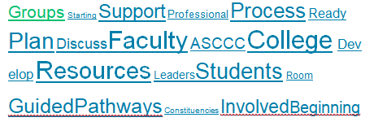

Ways ASCCC Can Help.
“Q14. What can the ASCCC Guided Pathways Task Force do to support your academic senate and/or local faculty with designing and/or implementing a guided pathways framework at your college?”
Need | Respondents
Sharing effective practices and evidence of their effectiveness | 15
Education regarding the role of senate/faculty, defining faculty-led for faculty and others & governance models | 12
Sharing of models and best practices | 10
Not sure/Don’t know | 9
Local visits desired/assistance with the difficult conversations | 6
On-going guidance | 3
Support for local GP leaders | 3
Regional meetings | 3
Assistance developing pathways locally and educating about Guided pathways more generally | 3
More data and better understanding of the case making and data | 3
Broaden the focus of GP beyond those students who can take 15 units/ensure focus is truly appropriate to CCCs | 2
Emphasize local innovation | 2
Emphasizing the effect across the college e.g. what happens in English and Math effects Psychology and Engineering | 2
More information for adjuncts | 2
Help with intentional resource allocation | 1
Assistance with “case-making” and access to experts | 1
Working with other constituencies | 1
Improved technology | 1
Remote support desired | 1
Dealing with territoriality or threatened programs | 1
Emphasize role and value of choice | 1
Involving all stake holders – classified, students etc | 1
Help on how funding can be used | 1
Sample comments:
“It would be helpful at Plenary and/or Regional Workshops to see models/examples of how colleges have implemented various components of Guided Pathways. Such as: academic advising by faculty; development and naming of meta-majors; collecting/sharing information on employment outlooks (especially for non-CTE programs); development of Basic Skills and GE courses that support students in a meta-major or specific program; etc.”
“We, as a college, are in desperate need of help from the ASCCC Guided Pathways Task Force. It is the opinion of our Academic Senate that we have been working diligently, openly and completely with in our purview to act in the best interest of our college and for our students. And, that it appears this effort is not being valued or met positively by the Administration of our college. The Academic Senate is very ways roll out, since by all measures we seems to be far behind and also appear to be working with an Administration that does not value collaboration with the Academic Senate.”
“More information for adjunct faculty and department chairs on the need for guided pathways would be helpful. The departments and the faculty need to understand the whole college and not their areas, that what happens in an English or Math class impacts a student majoring in Psychology or Engineering. Departments need to understand how other departments can help them out, in order to help the student out.”

Participating Colleges
–Allan Hancock College | –Hartnell College | – Sacramento City College
–American River College | –Imperial Valley College | –San Bernardino Valley College
–Bakersfield College | –Irvine Valley College | –San Diego Mesa College
–Butte College | –Los Angeles City College | –San Diego Miramar College
-Cabrillo College | –Los Angeles Mission College | –San Francisco, City College of
–Canada College | –Los Angeles Pierce College | –San Joaquin Delta College
–Canyons, College of the | –Los Angeles Valley College | –San Jose - Evergreen CCD
–Cerritos College | –Los Medanos College | –Santa Ana College
–Cosumnes River College | –Marin, College of | –Santa Barbara City College
–Cuesta College | –Mendocino College | –Santa Monica College
–Cuyamaca College | -Merced College | –Santa Rosa Junior College
–Cypress College | –Mission College | –Santiago Canyon College
–De Anza College | –Modesto Junior College | -Sequoias, College of
–Diablo Valley College | –Moorpark College | –Shasta College
–East Los Angeles College | –Moreno Valley College | –Sierra College
–El Camino College | –Mt. San Antonio College | –Skyline College (6)
–El Camino College Compton Center (9) | –Mt. San Jacinto College | –Southwestern College
–Evergreen Valley College | –Norco College | –Taft College
–Folsom Lake College | –Palo Verde College | –Ventura College
–Fresno City College | –Palomar College | –West Hills College Coalinga
–Fullerton College | -Pasadena City College | –West Los Angeles College
-Glendale College | -Peralta CCD | –West Valley College
–Grossmont College | -Reedley College | –Yuba College

Question Responses:
Question 4. Is your college currently participating in the AACC Pathways Project, the California Guided Pathways Project, or the Chancellor’s Office Guided Pathway Award Program? Select all that apply.
ANSWER CHOICES– | RESPONSES–
AACC Pathways Project | 5.80%  4
California Guided Pathways Project | 39.13%  27
Chancellor’s Office Guided Pathway Award Program | 63.77%  44
Unsure | 10.14%  7
No, my college is not participating in any guided pathway program at this time. | 11.59%  8
Total Respondents: 69

Question 5. How do you characterize the level of interest or support among faculty in investigating the design and implementation of a guided pathways framework at your college?
ANSWER CHOICES– | RESPONSES–
Significant Interest | 26.09%  18
Quite a bit of interest | 30.43%  21
Some interest | 36.23%  25
A little interest | 5.80%  4
No interest | 1.45%  1
Unsure | 0.00%  0
TOTAL | 69

Question 6. What is the level of campus-wide support for investigating the design and implementation of a guided pathways framework to at your college?
ANSWER CHOICES– | RESPONSES–
Significant interest | 34.43%  21
Quite a bit of interest | 37.70%  23
Some interest | 24.59%  15
A little interest | 1.64%  1
No interest | 0.00%  0
Unsure | 1.64%  1
TOTAL | 61

Question 7. Do you have access to the data you need regarding your local college guided pathways efforts and the resources to interpret it?
ANSWER CHOICES– | RESPONSES–
–  Yes | 73.53%  50
–  No | 14.71%  10
–  Unsure | 11.76%  8
TOTAL | 68

There were 11 comments primarily indicating:
- Swirl within districts needs clarification and better data tracking
- Research teams are understaffed
- Data literacy training is a need
- Contextualizing data is important
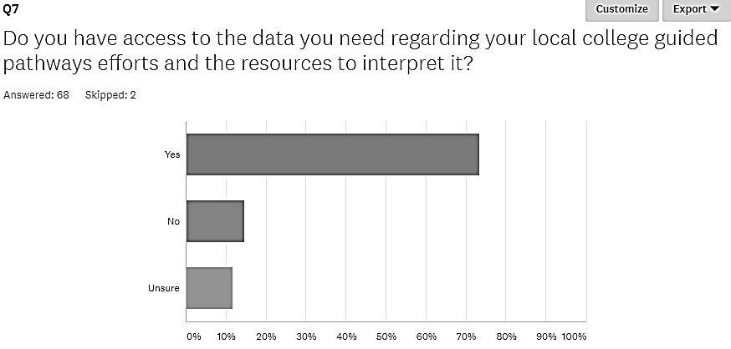

Question 8. Is the process to investigate the design and implementation of a guided pathways framework on your campus faculty driven?
ANSWER CHOICES– | RESPONSES–
–  Yes | 68.85%  42
–  No | 31.15%  19
TOTAL | 61
45 comments on this question are analyzed above
9. Do you feel that you have sufficient voice in the process through the shared governance as you begin to discuss a guided pathways framework? Three main areas of comment from highest to lowest:
1) Faculty Driven, 2) Rough Start now getting on track, 3) Collaborative teams, 4) Admin driven
ANSWER CHOICES– | RESPONSES–
–  Yes | 90.91%  50
–  No | 9.09%  5
TOTAL | 55
Comments(26)
(Multiple responses adjusted - Compton 9, Skyline 6, Santa Rosa 2, Fresno 2, Los Medanos 2. The doubled entries were by one person in each case)

