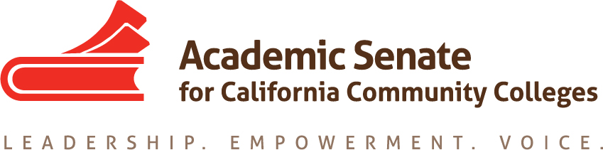

Transfer, Articulation and Student Services Committee

18 September 2019, 4 p.m.

Zoom

MINUTES

- Call to Order and Adoption of the Agenda
At 4 pm Sam Foster (chair) welcomed the committee members participating in today’s meeting: Anna Bruzzese, Jose Lara, Lorraine Burnham-Levy, Mark Osea and Miles Vega. The committee unanimously adopted the agenda

- Volunteer note taker
Anna volunteered to take minutes.

- Review Transfer Paper outline and Assignments
The committee reviewed the Effective Transfer Practices paper outline and assignments. The proposed outline will be discussed at the ASCCC Executive Committee next week in Riverside. Hopefully we can have something by next meeting.

- Fall Plenary Breakout Session on Transfer Pathways
  - Planning and breakout description
The draft Plenary program has been completed. Sam is working with Craig Rutan on a breakout on transfer pathways. This would be a good opportunity to get some feedback from the field on effective transfer practices. One thing to include would be to ask about staffing at Transfer Centers. Another thing to ask would be whether colleges are looking at policies such as academic renewal.
  - Presenters
Sam and Craig Rutan will be co-presenting. Sam asked if anyone else would like to co-present. Jose will check to see if he can attend. There are also scholarships available.

- Review of Resolution 7.01 F17 Creating Guidelines for Veteran Resource Centers
  - Possible ways to approach
The committee reviewed the resolution and talked about possible ways to approach it: a survey would be one option. Another option is to spotlight successful transfer centers. In a survey we would also ask about whether respondents know of any centers outside of California, and if they can provide contact information. Sam will also reach out to Michael Wyly, the author of the resolution.
  - Possible timeline
We would need to start working on the survey fairly soon, if it is to be sent out and completed in spring. We’d need an approved version by March 2020. Sam will include this item on each agenda, and we will start working on the survey that way.

- Review of Resolution 7.02 S18 Wrap-Around Services and Online Student Success
  - Possible ways to approach
The committee reviewed the resolution and talked about online counseling, tutoring and other services: health centers, student life, veteran centers, the library, etc. Sam will reach out to the ASCCC President John Stanskas for some more directions. Mark shared the link to the 2017 Distance Education Report which contains the relevant information>
https://www.cccco.edu/-/media/CCCCO-Website/About-Us/Reports/Files/2017-DE-Report-Final-ADA.ashx?la=en&hash=4355069E3B2E3371FBF401A0788013DD0188EE3D
  - Possible timeline
After Sam talks to John, we will have a sense of possible direction and timeline.
- Future Meetings
  - Next Zoom meeting October 9 at 4 p.m.
  - In-Person Meeting January 31 at Rio Hondo College

- Other Items for Discussion
  - Student Service Area outcomes – Sam inquired about whether all the committee members’ colleges have Student Service Area outcomes. Most have them and will send them to Sam.

- Announcements/Events
  - Executive Committee Meeting – Riverside – September 27-28, 2019
  - Area Meetings – Various locations – October 13, 14
  - Executive Committee Meeting – Newport Beach – November 6, 2019
  - Fall Plenary Session – Newport Beach – November 7-9, 2019

- Adjournment
The meeting adjourned at 5:23 pm.
Minutes respectfully submitted by Anna Bruzzese.

