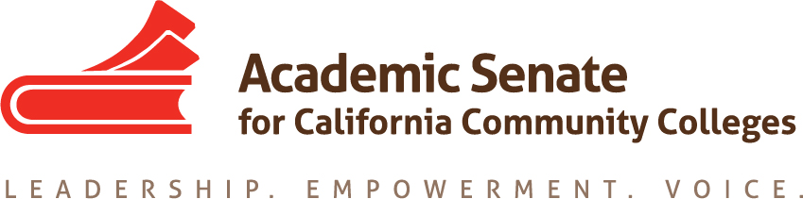

Transfer, Articulation, and Student Services Committee (TASSC)
March 7, 2016 – 12:00-1:00
CCC Confer
Dial your telephone conference line: 1-913-312-3202*
Participant Passcode: 701790
*Toll free number available: 1-888-886-3951

MINUTES

Members Present: Ginni May (Chair), Dolores Davison (2nd), Michael Wyly, Trevor Rodriguez, April Pavlik, Shuntay Taylor, Vicki Maheu

Members Absent:

- Select note taker – Dolores

- Approval of the Agenda -- approved

- Approval of the Minutes from January 27, 2016 – done by email

- Survey and article on Services for Disenfranchised Students – update
  - Will ask to have survey sent out to counselors as well so that we can get more information
  - Article and survey have been sent out
  - Results will be used by next year’s committee, as results will probably not be available in time for us to use this year.

- Academic Academy 2016 – EDAC and TASSC
- Contact presenters: Power Points and other materials due Monday, March 14:
- Next Steps: send PPTs to Ginni for posting; please get presenter bios

- Spring Plenary Session 2016
- Who is going? Michael; Vicki (possibly); April; Shuntay
- Breakout from TASSC – Disenfranchised Students, Thursday, April 21, 3:45-5:00
Description due March 16 – Ginni has written up a brief paragraph and title for the breakout; should we reference equity in the description? How and where is it appropriate to connect these conversations? Address in the PPT rather than the description
- Spring Fling – Thursday, April 21, 6:00-9:30 at MIX Downtown -- $75.00 tickets include appetizers and two drink coupons
- Auction – need donations
- ASCCC Elections: At-Large, South Rep, North Rep, Area B, Area C, all officers

- TASSC Meetings
- April 11, 12:00-1:30 (Monday) disenfranchised students breakout, AP scores
- May 2, 12:00-1:30 (Monday) wrap up, summarize work this year, direction for next year
- Future Agenda Items – possible AP scores resolution or Rostrum article coming forward

- Events
Academic Academy – March 18-19, Sheraton Sacramento
Area Meetings – April 1 (North-Areas A, B), April 2 (South-Areas C, D)
Area A—Butte College
Area B—College of Marin
Area C—Ventura College
Area D—Cypress College
Online Education Regionals – April 8 (North—College of San Mateo), April 9 (South—Glendale College)
Noncredit Regionals – April 15 (North—TBA), April 16 (South—TBA)
Spring Plenary Session – April 21-23, Sacramento Convention Center
CTE Institute – May 6-7, Double Tree, Anaheim
Faculty Leadership Institute – June 9-11, Riverside
Curriculum Institute – July 7-9, Anaheim

