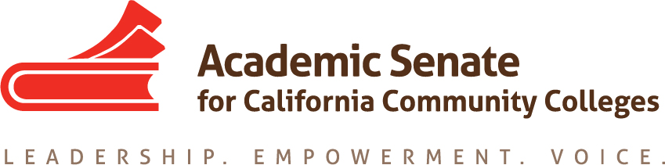

Transfer, Articulation, and Student Services Committee (TASSC)
May 2, 2016 – 12:00-1:00
CCC Confer
Dial your telephone conference line: 1-913-312-3202*
Presenter Passcode: 2479691
Participant Passcode: 179729
*Toll free number available: 1-888-886-3951

MINUTES

Members Present: Ginni May (Chair), Dolores Davison (2nd), Vicki Maheu, April Pavlik, Trevor Rodriguez, Shuntay Taylor, Michael Wyly

Members Absent:

- Select note taker – Dolores Davison

- Approval of the Agenda – Approved by consensus

- Approval of the Minutes from April 11, 2016 – Approved by committee

- Spring Plenary Session 2016 – Report
- Breakout from TASSC – Disenfranchised Students, Thursday, April 21, 3:45-5:00
  - April, Shuntay, Ginni, Michael: feedback from folks that could not be there; breakout went really well, lots of positive feedback; well received and informed subsequent resolution. Where to go next: good steps spelled out by April.
  - Discussion was about services already provided as well as those who have no services – audience recognized that most services are provided for targeted or cohorts, and that where general resources exist, they are sporadic and not centralized; very few examples of centralized efforts; audience seemed to understand what the breakout focus was
- Thank you, Shuntay, who donated wine
- ASCCC Elections Results -- Julie Bruno (President); John Stanskas (Vice-President); Dolores Davison (Secretary); John Freitas (Treasurer); Cleavon Smith (Area B); Cheryl Aschenbach (North); Area C (Adrienne Foster); At-Large (Lorraine Slattery-Farrell); Randy Beach (South); Sam Foster (South); Conan McKay (at-large)
- Resolution on AP Credit and AB 1985 (Williams) – Passed

- Services for Disenfranchised Students – Next steps for TASSC
https://www.surveymonkey.com/results/SM-X73LCNSW/
We have the results; need to be analyzed by next year’s committee and possibly do a paper or other material about the survey; possible take this to exec and the Foundation to ask for direction; also look at article in Rostrum and presentation and come up with a recommendation going forward; Ginni will bring item to May exec meeting.

- Best of Rostrum Articles http://asccc.org/directory/transfer-articulation-and-student-services-committee
When are Counseling Paraprofessionals Appropriate? A Friendly Reminder, April 2010

- Recommendations for next year’s committee
  - Continue work on disenfranchised students
  - Reciprocity issues – articulation officers have concerns about it being too restrictive;
  - Noncredit transfer issues
  - AP Credit

- TASSC Meetings – this is it! Please submit a request to serve form if you are interested!

- Events
CTE Institute – May 6-7, Double Tree, Anaheim
Faculty Leadership Institute – June 9-11, Riverside
Curriculum Institute – July 7-9, Anaheim

10. Adjourned at 12:44pm

