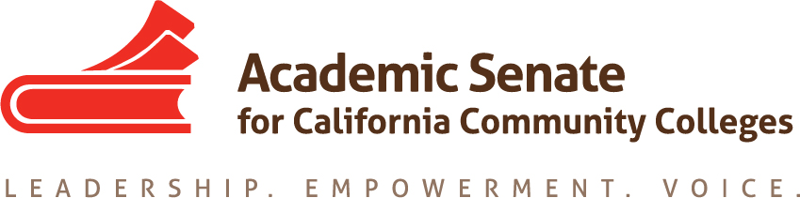

Transfer, Articulation, and Student Services Committee (TASSC)
August 27, 2015 – 10:00-3:00
Long Beach City College
MINUTES

Members Present: Ginni May (Chair), Dolores Davison (2nd), Michael Wyly, Trevor Rodriguez, April Pavlik, Shuntay Taylor
Members Absent: Vicki Maheu

- Introductions, select note taker (Dolores Davison)

- Committee Charge
Reviewed the committee charge and confirmed the roster.

- Priorities
- Resolution – F14 20.01 Developing A System Plan for Serving Disenfranchised Students: Have revised survey ready for October Executive Committee meeting so that survey can be sent out in fall 2015 and reported on in spring 2016. The committee reviewed and made edits to the survey. Dolores will send Ginni the notes. Ginni will clean up the survey and send to the committee for comments and additional edits. Final survey will be ready by September 15 for Executive Committee. In addition, the committee will write a Rostrum Article on Disenfranchised Students. Committee members will send information on disenfranchised students to Ginni by September 19. Ginni will organize the information into an article and circulate for feedback and edits. The committee plans to submit the article by the October 12, 2016 deadline.
- Counseling role regarding Bachelor’s degrees: The committee had the following questions: What will be the role? How will applications to bachelor degree programs work? It is difficult for us to give a message to the counselors if we’re not certain what the role will be. Ask Executive Committee if we could/should do a survey of the schools that are in the pilot to see what they need? Should we wait for direction? If we do a survey:
    - Send to Senate Presidents, Articulation officers, VPSS, counselors, deans of counseling, transfer center staff
    - Write a Rostrum article after survey
- STARFISH – Early Alert System http://www.starfishsolutions.com/home/starfish-enterprise-success-platform/starfish-early-alert/
    - Student Services portal: used to serve as a conduit between colleges and third party vendors;
    - Concerns regarding workload, FERPA: do the students want all this information sent about them? Who would have access to this information?
    - Currently being investigated by pilot colleges: how is it working for them?
- Who will use it? How will it be used? Support for counselors? Involvement of IT; integration into native/existing system
- Invite pilot colleges to report out at plenary; what should we be looking at?
- Wait for direction from the Executive Committee about where this information is to be presented.
- How will the DAS work for transfer students?

- Other resolutions for committee
- S08 13.04 Effective Practices for Online Tutoring
A paper might not be appropriate at this point; Reach out to the OEI regarding tools and vetting of online tutoring.
- F11 11.01 Consultation Regarding Technology Tools Impacting Student Services
Necessary involvement of counselors; should we declare it completed? Revisit resolution? The committee felt this resolution was completed with EPI. It could be communicated to the field through a breakout.

- Regionals, Academies, Institutes
- CTE Regional Meetings: Committee members will attend if possible.
- Fall Plenary, Irvine Marriott, Nov. 5-7—BREAKOUT TOPICS:
- Difference between academic advisors, counselors, paraprofessionals
- UC Pathways and articulation: differences with ADTs and UC Pathways, Advising and articulation
- Articulation with Bachelors Degrees: Transfer and articulation between CCCs
- Career Technical Education Curriculum Academy, Napa Valley Marriott, Jan. 14-15
- Instructional Design and Innovation, Riverside Convention Center, Jan. 21-23—BREAKOUT TOPICS
- STARFISH presentation
- Accreditation Institute, Marriott Mission Valley San Diego, Feb. 19-20
- Academic Academy, Sheraton Sacramento, March 17-19
- Spring Plenary, Sacramento Convention Center, April 21-23
The Committee recommended having a BREAKOUT on Minimum Qualifications, Equivalent Qualifications, and Hiring since faculty and admin would be at this plenary.

- Workforce Taskforce Update and Direction
- ASCCC CTE Regional Meetings: North-Fri 10/9, South-Sat 10/10, Bay-Fri 10/16, Central-Sat 10/17
- http://doingwhatmatters.cccco.edu/StrongWorkforce.aspx Read Draft Report to BOG
- committee comments
i. Recommendation #5: tracking of students from high school and across disciplines; concerns about access for student information; federated id; FERPA
ii. Recommendation #6: support services for students; how is that data going to be used to support students? Two parts of statement are two different issues.
iii. Minimum qualifications – discussion about baccalaureate degrees should involve the work force.

- Rostrum Articles – due Oct. 12, 2015
The Committee is going to write a Rostrum Article on Disenfranchised students. This article is meant to inform the field about disenfranchised students and also help improve the responses to the Survey going out in response to Resolution F14 20.01.

- Set up next meetings:
September 9, 2015 10:00-11:00 by phone
October 14, 2015 12:30-1:30 by phone
December 11, 2015 10:00-3:00 in person TBA

