Community College Regional Consortia

Bay Area
baccc.net
Co-Chair:  Rock Pfotenhauer  rock@baccc.net  831.212.7207 | Co-Chair:  Kit O'Doherty  kit@baccc.net  650.274.5236 | Colleges  - Berkeley City  - Cabrillo  - Canada  - Chabot  - City College of San Francisco  - College of Alameda  - College of Marin  - College of San Mateo  - Contra Costa  - De Anza  - Diablo Valley  - Evergreen Valley  - Foothill  - Gavilan | - Hartnell  - Laney  - Las Positas  - Los Medanos  - Merritt  - Mission  - Monterey Peninsula  - Napa Valley  - Ohlone  - San Jose City  - Santa Rosa Junior  - Skyline  - Solano  - West Valley
Priority Sectors: Advanced Manufacturing; Advanced Transportation & Logistics; Health; Information & Communication Technologies (ICT)/Digital Media; Public Safety

Bay Area Regional Workforce Plan – Overarching Goals
Goal A: Provide pathways that enable all Bay Area students to find employment and advance to livable wages.

Goal B: Meet the needs of employers in the Bay Region for well-qualified candidates for positions that pay livable wages, particularly in labor market priority* areas.
Goal C: Ensure equity in participation, completion, and employment.

Central/Mother Lode
crconsortium.com
Chair:  Dr. Jessica Grimes  jessica.grimes@crconsortium.com  https://crconsortium.com/  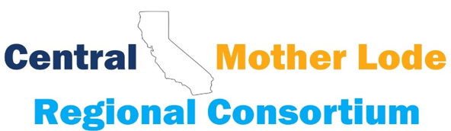 |  | Colleges  - Bakersfield  - Cerro Coso  - Clovis Community  - College of the Sequoias  - Columbia  - Fresno City  - Madera | - Merced  - Modesto Junior  - Porterville  - Reedley  - San Joaquin Delta  - Taft  - West Hills Coalinga  - West Hills Lemoore
Priority Sectors: Advanced Manufacturing; Agriculture, Water & Environmental Technologies (AWET); Business & Entrepreneurship; Energy, Construction & Utilities; Global Trade; Health; Information & Communication Technologies (ICT)/Digital Media; Retail/Hospitality/Tourism

CRC Strong Workforce Regional Plan – Overarching Goals
A. Regional Leadership & Communication - Cultivate and develop regional leadership and support structures that improve outcomes in the region’s priority sectors.
B. Regional Planning - Intentional planning and deliberate collaboration to prepare students to enter the workforce educated for tomorrow's jobs in pathways supported by labor market data in the CRC's industry sectors that offer living wage and higher paying, middle-skill jobs.
C. Curriculum, Programs and Pathways - Build and Clarify the Path.
D. CTE Student Support Services - Enter the Path, Stay on the Path and Ensure Learning, Employment Preparation and Transition to Work.
E. Research and Data - Foster the use of data (Launchboard, LMI, etc.), inquiry, and evidence to achieve SWP metrics and Vision for Success.

Inland Empire/Desert
www.desertcolleges.org
Chair:  Julie Pehkonen  Julie.Pehkonen@rcc.edu  951.222.8026 |  | Colleges  - Barstow  - Chaffey  - College of the Desert  - Copper Mountain  - Crafton Hills  - Moreno Valley | - Mt. San Jacinto  - Norco  - Palo Verde  - Riverside City  - San Bernardino Valley  - Victor Valley
IEDRC Strong Workforce Regional Plan – Overarching Goals
Goal A. Reinforce efforts to address issues of diversity, equity, inclusion, and accessibility in the region’s career education programs.
Goal B. Support relevant and valuable career education opportunities for students via distinct paths in K-12 and community college.
Goal C. Strengthen initiatives that facilitate student course and program completion in career education paths.
Goal D. Expand and enrich stakeholder relationships to support students’ transition into and progress within the labor market.

North/Far North
www.nfnrc.org
Executive Director:  Blaine Smith  smithbl@butte.edu  northstatecareers.org |  | Colleges  - American River  - Butte  - College of the Redwoods  - College of the Siskiyous  - Cosumnes River  - Feather River  - Folsom Lake | - Lake Tahoe  - Lassen  - Mendocino  - Sacramento City  - Shasta  - Sierra  - Woodland  - Yuba
Priority Sectors:
Advanced Manufacturing, Advanced Transportation & Logistics, Agriculture, Water & Environmental Technologies (Ag, WET), Business & Entrepreneurship, Education & Human Development, Energy, Construction & Utilities (ECU), Health, Information & Communications Technologies/Digital Media (ICT/Digital Media), Life Sciences & Biotechnology, Public Safety & Government, Retail, Hospitality & Tourism
NFNRC Strong Workforce Regional Plan – Overarching Goals
Vision for Success Goals
- Increase number of students who acquire associate
- degrees, credentials, certificates, or specific skill sets that prepare them for an in-demand job
- Increase number of students transferring to a UC or CSU system
- Decrease the average number of units accumulated by community college students earning associate degrees
- Increase the percent of exiting CTE students who report being employed in their field of study
- Reduce equity gaps across all measures through faster improvements among traditionally underrepresented student groups
- Reduce equity gaps across all measures through faster improvements among traditionally underrepresented student groups
NFN Regional Goals
- Improve coordination of workforce training
- Improve responsiveness to employers
- Increase equitable student completions
- Further organizational effectiveness

Orange County
www.ocreginoalconsortium.org
Adriene "Alex" Davis, Ed.D.  Executive Director/Regional Chair  Orange County Regional Consortium (OCRC)  davis_adriene@rsccd.edu  714.564.5575 | Sarah Santoyo  Fiscal Agent Director  Orange County Regional Consortium (OCRC)  Host: Rancho Santiago CCD  santoyo_sarah@rsccd.edu  (714) 480-7466
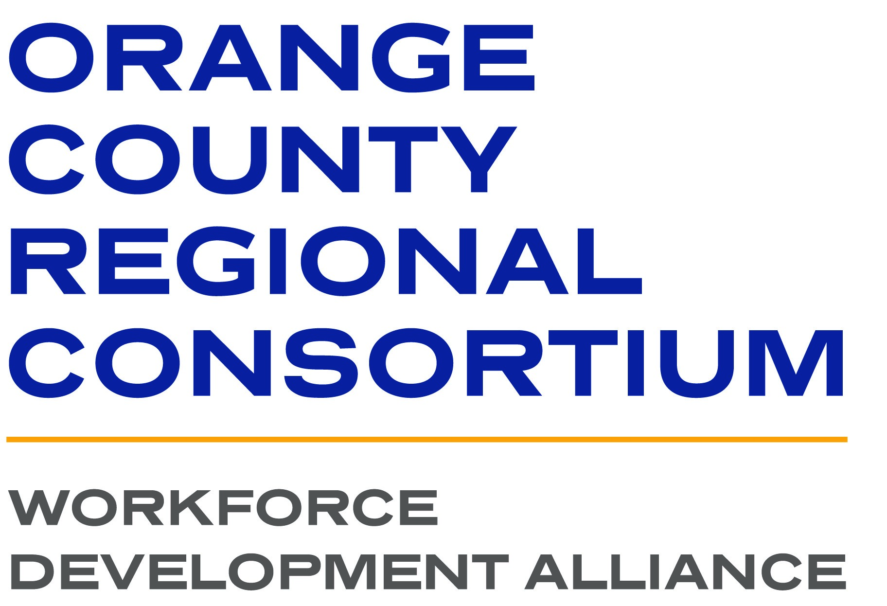 | Colleges  - Coast Community College District  - Coastline College  - Golden West College  - Orange Coast College  - North Orange County Community College District  - Cypress College  - Fullerton College  - North Orange Continuing Education  - Rancho Santiago Community College District  - Santa Ana College  - Santiago Canyon College  - South Orange County Community College District  - Irvine Valley College  - Saddleback College
Priority Sectors: Advanced Manufacturing; Advanced Transportation & Logistics; Business & Entrepreneurship; Energy, Construction & Utilities;
Health; Information & Communication Technologies (ICT)/Digital Media; Life Sciences/Biotech, Public Safety & Government, Education & Human
Development, and Retail, Hospitality & Tourism

Orange County Regional Consortium Strong Workforce Regional Plan
The Orange County Regional Consortium (OCRC) consists of nine community colleges and one continuing education center across four community
college districts, and serves as a regional framework for communicating, coordinating, collaborating, promoting and planning career and technical
education, and workforce and economic development initiatives in the Orange County Region. The goal of the OCRC is to support the connection of
individuals and the alignment of programs and curriculum to the needs of business & industry.
Regional Collaboration/Coordination Objectives Employer Engagement Objectives
Employer Engagement Regional Strategy WBL, Apprenticeships, Internships, and Faculty Externships
Develop and Support Career Pathways Program Career Placement
Increase Middle-Skill, Industry-Valued Credentials Comprehensive Supports & Pathways, APL, and Articulation
Target Unemployed and Low-Income Residents Industry Training and Education
Increase Completions, Graduation Rates, and Reduce Units

San Diego/Imperial
www.myworkforceconnection.org
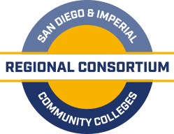  Chair:  Danene Brown, Ph.D.  danene.brown@gcccd.edu  619.644.7815 | 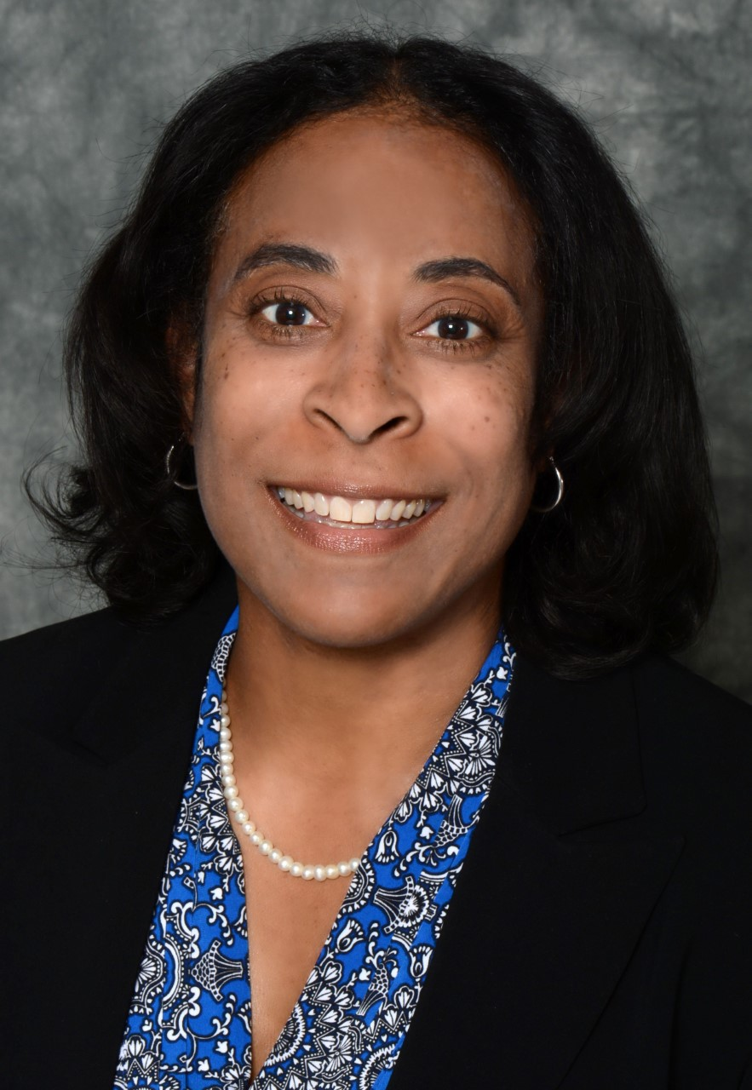 | Colleges  - Cuyamaca  - Grossmont  - Imperial  - Mira Costa  - Palomar | - San Diego Continuing Education  - San Diego City  - San Diego Mesa  - San Diego Miramar  - Southwestern
Priority Sectors: Advanced Manufacturing; Advanced Transportation & Logistics; Business & Entrepreneurship; Energy, Construction & Utilities; Health; Information & Communication Technologies (ICT)/Digital Media; Life Sciences/Biotech, Public Safety & Government, Education & Human Development, and Retail, Hospitality & Tourism

San Diego/Imperial Regional Consortium Strong Workforce Regional Plan
The San Diego & Imperial Counties Regional Consortium (SDIC RC) is comprised of 10-member Community Colleges, and is committed to providing leadership and guidance on regional career education initiatives that serve its members and stakeholders. Driven by an equity framework, we collaborate with educators, industry, and community partners to support students, develop and sustain a skilled workforce, and align to the needs of the regional ecosystem.

- Equity
- Career Pathways
- Pathway Navigation
- Employer Engagements: Employment readiness, work-based learning and job placement
- Retention, Success and Supports
- Sector Investments
- Data/Research - Labor Market Information and Gap Analysis
- Marketing

Employer engagement is central to aligning our programs of study with industry needs, providing work-based learning for our students and job placement opportunities for our students. All of our investments are grounded in data research.

South Central Coast
www.sccrcolleges.org
Chair:  Holly Nolan Chavez  hchavez@vcccd.edu | Fiscal Agent Director:  Luann Swanberg  lrswanberg@pipeline.sbcc.edu | Colleges  - Allan Hancock  - Antelope Valley  - College of the Canyons  - Cuesta | - Moorpark  - Oxnard  - Santa Barbara  - Ventura
Priority Sectors: Advanced Manufacturing; Public Safety; Health; Information & Communication Technologies (ICT)/Digital Media

SCRC Strong Workforce Regional Plan – Strategic Goals
- Strengthen communication, coordination, and timely decision-making in regional CTE efforts.
- Enhance participation in CTE Career Pathways between K-16.
- Reinforce regional leadership and operational partnerships among K12, community colleges, industry, labor, and other workforce and economic development entities to improve the delivery of all CTE efforts.
- Align college programs with local and regional and industry needs and provide support for CTE programs.
- Create a public outreach campaign for industry, high school students, counselors, parents, faculty, staff, and the community at large to promote career development and attainment and the value of career technical education.

Los Angeles Regional Consortium
www.losangelesrc.org
Dr. Narineh Makijan  Chair/Assistant Vice President  nmakijan@pasadena.edu  818.445.4750 |  | LARC Colleges  Community College District (CCD)  1. Cerritos CCD  2. Citrus CCD  3. El Compton CCD  4. El Camino CCD  5. Glendale CCD  6. Long Beach CCD  7. Mt. San Antonio CCD  8. Pasadena Area CCD  9. Rio Hondo CCD  10. Santa Monica CCD | Los Angeles Community College District (LACCD)  1. East Los Angeles College  2. Los Angeles City College  3. Los Angeles Harbor College  4. Los Angeles Mission College  5. Los Angeles Trade-Technical  College  6.Los Angeles Southwest College  7. Los Angeles Valley College  8.Pierce College  9. West Los Angeles College
The Los Angeles Regional Consortium (LARC) consists of 19 community colleges across 11 community college districts. LARC serves as a central hub to communicate, coordinate, collaborate, promote, and plan career and technical education and workforce and economic development in the Los Angeles region. The consortium also serves as a single point of entry for emerging and high-growth industries looking to partner with the network and recruit community college graduates.

Priority Sectors: Advanced Manufacturing, Advanced Transportation & Logistics, Business & Entrepreneurship/Global Trade, Energy, Construction & Utilities, Health, Information and Communication Technologies (ICT)/ Digital Media, Life Sciences and Biotech, Retail, Hospitality, & Tourism (Emerging Sector)

LARC Strong Workforce Regional Plan – Overarching Goals
1. Consciously and intentionally infuse diversity, equity, and inclusion in all strategies and activities.
2. Maximize sustained industry engagement.
3. Strengthen CE career pathways and programs of study.
4. Implement strategies and activities to help students complete the CE pipeline.
5. Address the needs of business and industry in identified priority and emerging sectors.
6. Demonstrate the regional impact of SWP investments.

Regional Plan 2023: https://losangelesrc.org/wp-content/uploads/2023/02/LARC-Regional-Plan-Report-1-31.pdf

