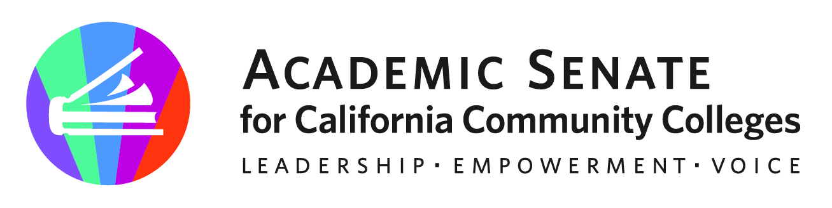
f

ASCCC CTE Leadership Committee

September 1, 2023

12:00pm – 1:00pm

Via Zoom

Meeting Summary

Members (* notes Present)
Stephanie Curry – Chair* | John Grounds* | Marie Templo-Capule*
Christopher Howerton – 2nd Chair* | Alexander Jones* | Sigrid Williams
Amar Abbott* | Nicole Marquez*
Jimmie Bowen* | Brian Palmiter* | Lynn Shaw*
Alana Gates* | Stephanie Rowe*

- Call to Order and Adoption of the Agenda
- The meeting was called to order at 12:01pm.

- Welcome and Introductions
  - The chair welcomed the new members of the CTELC and members had a chance to introduce themselves.

- Review of Committee Charge
  - The committee reviewed the charge statement below and discussed the role of this committee as it relates to the overall work of ASCCC. Specifically making recommendations and supporting professional development.
  - The chair also shared information about the committee website and opportunities to signup for various listservs to keep informed.

Per California Education Code, Part 54.5, section 88821, the CTE Leadership Committee provides recommendations on career and technical education and workforce development issues and challenges in the California community colleges. The committee works collaboratively with the ASCCC Executive Committee to provide assistance to community college districts, CTE departments, and CTE faculty in creating and maintaining responsive and system-wide portable curriculum courses, programs, and degrees aligned to current and emergent industry trends, guided pathways, and to focus on diversity, equity, and inclusion in all aspects of career education. The committee is also focused on diversity by expanding the participation of diverse CTE faculty in leadership roles at the local, regional, and statewide levels through its ongoing professional development efforts. (updated June 4, 2021)

- Review of 2022-2023 Committee End of Year Report and Recommendations
  - The chair shared the previous year’s EOY report to orient the committee on work completed last year and use to consider our work for this coming year.
  - Highlighted the regionals from last year and the recommendations to create more local F2F opportunities. Specifically connecting more with each region and collaborative events. The chair did note that the membership on this committee holds representations from all the various regions.

- ASCCC and Regional Consortium Collaboration (Planning and Participation)
  - The chair shared the status on the planning for the series of approved regional collaborations. The goal is to encourage more faculty input and participation.
  - Actual and draft dates are below.
  - These events are cohosted by ASCCC and the various regional consortiums.
  - The chair shared the current planning that has been done for the first two regionals including draft agenda (menu of options) and logistics.
  - CTELC members are encouraged to attend these events in their area. ASCCC is not able to support member travel to these events, but may check in with local college opportunities to support participation/attendance.
  - Communication about these events will be shared with various liaisons and other listservs.
  - The chair will also conduct direct communication to the local senates represented by various areas prior to the regional events.

Earlier this year the Exec Committee approved collaboration events with the Regional Consortium. The Exec Committee is being asked to approve the proposed collaboration dates.

Eight CTE Collaborative Events with Regional Consortiums

- Orange County 10-3 September 21,2023 (space up to 200) Minimum Qualifications)
- South Central Coast October 6, 2023
- Inland Empire: February 9, 2024 10-3
- Central/Mother Lode: February 2nd
- North Far North (NFN) February 16th, 2024 from 10-3
- San Diego/Imperial March 8, 2024
- LA May 3, 2024 9-2
- Bay Area (BACCC) CTE Minimum Qualifications morning 1.5 hours : 10-3 May 10, 2024

- Proposed Resolutions Fall 2023
  - The chair discussed our ASCCC resolution process and specifically how these resolutions direct our work as an organization and standing committees.
  - The committee was shown the resolution database and how to search for specific resolutions/topics for our committee.
  - The chair also shared the opportunity for our committee to draft and submit new resolutions for emerging needs as it relates to CTE work.

- Proposed Professional Learning
  - Presented in various ways (e.g. Rostrum, webinars, events, sessions at Plenary/other institutes)
  - Topics below could be considered as professional learning as well as Rostrum articles.
  - Nontraditional and apprenticeship to demystify for faculty and resources to be highlighted with benefits/success for students, etc.

- Rostrum Brainstorming

  - Possible topics from our committee for the Rostrum publications initially shared, such as gender in CTE or other CTE Hot Topics, nontraditional employment for women in these fields, highlighting outstanding CTE programs from each region, etc.
  - There are three deadlines for submissions this academic year. October 1st is the next upcoming deadline.
  - Implementing new guidance around work experience, CBE (Competence Based Education), and CPL (Credit for Prior Learning) are also considerations.
    - Lynn shared the following definitions:
      - CBE is a flexible approach to teaching and learning in which students earn certificates and degrees by demonstrating that they've mastered and can successfully apply the knowledge and skills required for a particular job or career. This approach has clear benefits to students, employers, and the state: •
      - Credit for Prior Learning: To accommodate the realities of the working world, the California Community Colleges provide credit for prior learning to students who have gained skills and knowledge outside the classroom. Credit for prior learning gives students a jumpstart on completing their degree and entering the workforce, with some students saving an average of 6 to 10 months.

- Future Meetings
  - We will set a next meeting for later in September. The chair will send out another doodle poll to set a meeting.

- Upcoming Events

  - The following upcoming ASCCC events were shared.

2023 Accreditation Institute | September 29-30, 2023
Central Coast Regional Collaborative Event | October 6, 2023
Inland Empire Regional Collaborative Event | October 13, 2023 will be in Feb.
Fall 2023 Plenary | November 16-18, 2023

- Adjournment
  - The chair shared that we will be using the end section of our agendas to keep track of our work.
  - It is recommended to set up a google drive/file to store committee documents. The chair will follow up. Meeting adjourned at 1:03pm

Status of Previous Action Items

- In Progress (include details about pending items such as resolutions, papers, Rostrums, etc.)

- Completed (include a list of those items that have been completed as a way to build the end of year report).

