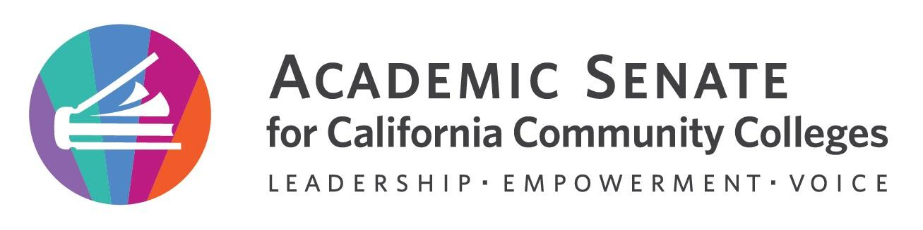
;;

Education Policies Committee Meeting

Wednesday, February 15th, 2023

12:00 p.m. – 1:00 p.m.
The Educational Policies Committee studies educational issues of concern to the Academic Senate and is the standing committee that recommends educational policies to the Executive Committee. The Committee provides a forum for high-level discussion and development of Academic Senate Policy, including its effect on faculty and students. The discussions include the viewpoint of students, CIOs and union representatives. The Educational Policies Committee researches issues as required, and writes background and/or position papers where appropriate. The Committee may pass general recommendations to other Senate committees, or work with them on more detailed implementation or technical issues. New or revised educational policies of the Academic Senate pass through the Educational Policies Committee. These may include policies to be implemented either locally or at the state level, suggested positions on proposed policies or changes in existing policies, and responses to assignments given by the President or Executive Committee.

MINUTES

- Call to Order and Roll Call:
The meeting was called to order at 12:02pm

Juan Arzola – 1st Chair | Stephanie Curry – 2nd | Maria Figueroa
Julie Clark | Lorraine Slattery | Christie Dam
Carlos Guerrero | Chantal Lamourelle | Matais Pouncil, CIO
Justin Maung, SSCCC Rep

- Land Acknowledgement –
Juan read the Land Acknowledgement.
We acknowledge that our campuses are located on unceded territories of Yokuts, Miwuk, Gabrielino, Tongva, Serrano, Cahuilla, and Luiseno peoples, who have continuously lived upon this land since time immemorial. We recognize the historic discrimination and violence inflicted upon Indigenous peoples in California and the Americas, including their forced removal from ancestral lands, and the deliberate and systematic destruction of their communities and culture. We have a responsibility to oppose all forms of individual and institutionalized racism toward all people but especially toward Indigenous peoples in which discrimination has occurred through the omission and silencing of Indigenous voices. We embrace our position as educators to collectively learn how to actively address settler colonial legacies. We honor Indigenous peoples—past, present, and future—here and around the world.

- Adoption of agenda, volunteer minutes taker, and Google Shared Folder 2022 – 2023.
The agenda and minutes were approved by consensus.

- 2009 Enrollment management update
Committee reviewed the comments and notes from the Executive Committee. Juan and Stephanie made the minor edits.
Goal is to complete edits by Feb 24, 2023 so we can get it out to Exec for review at March 2023 meeting.
- General Observations included the introduction- focus beyond the pandemic to include enrollment management including Guided Pathways and Racial Reckoning, AB 705 and AB 1705.
- Committee discussed how to identify new and old parts of the paper and acknowledge the work of the 2009 committee.
- Committee members are encouraged to review the entire paper and make comments and edits.
- Committees was asked to review the recommendations to make sure they are based on the paper.
- Will add a section on legislative impacts to enrollment

- Other Educational Policies Committee Matters
Juan is working on article with Cheryl.
  - Rostrum articles
      - Student Academic Dishonesty
      - Academic freedom: A need for legal definition? (Joint effort with Legislative Advocacy Committee)
Juan is continuing to work on article
  - Resolutions
- Adopt updated enrollment management paper
Committee reviewed draft. Members are asked to review the resolution and send updates by Friday February 17, 2023
- Changes to title 5 to define academic freedom- Juan is working on the resolution and will share with committee.

- Announcements
  - Check for upcoming events
    - 2023 Spring Plenary Session: April 20, 2023 – April 22, 2023, 8:00 am – 12:00pm
Chantel and Carlos will be attending plenary. There will be a breakout on Enrollment Management.
    - 2023 Spring Area Meetings: March 24, 2023 & March 25, 2023, 9:00 am – 4:00 pm
  - Application for Statewide Service

- Adjournment
The committee adjourned at 1:05pm

In Progress
- Enrollment management paper rewrite
- Student Academic Dishonesty rostrum paper
- Academic Freedom rostrum paper—joint project with Legislative Advocacy Committee

Completed Tasks:
- Established meeting norms and social agreements

