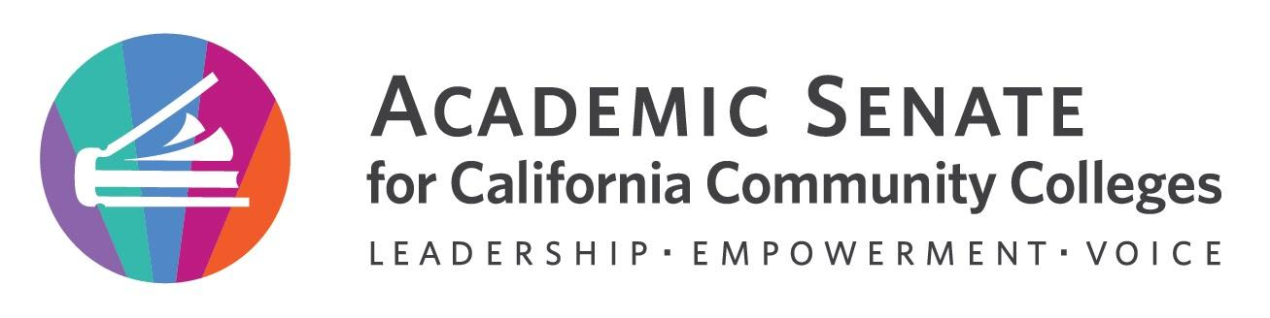
;;

Education Policies Committee Meeting

Wednesday, December 14th, 2022

12:00 p.m. – 1:00 p.m.
The Educational Policies Committee studies educational issues of concern to the Academic Senate and is the standing committee that recommends educational policies to the Executive Committee. The Committee provides a forum for high-level discussion and development of Academic Senate Policy, including its effect on faculty and students. The discussions include the viewpoint of students, CIOs and union representatives. The Educational Policies Committee researches issues as required, and writes background and/or position papers where appropriate. The Committee may pass general recommendations to other Senate committees, or work with them on more detailed implementation or technical issues. New or revised educational policies of the Academic Senate pass through the Educational Policies Committee. These may include policies to be implemented either locally or at the state level, suggested positions on proposed policies or changes in existing policies, and responses to assignments given by the President or Executive Committee.

Minutes

- Call to Order and Roll Call:
The meeting was called to order at 12:05pm

Juan Arzola – 1st Chair | Stephanie Curry – 2nd | Maria Figueroa
Julie Clark | Lorraine Slattery | Christie Dam
Carlos Guerrero | Chantal Lamourelle | Matais Pouncil, CIO
Justin Maung, SSCCC Rep

- Land Acknowledgement –
The land acknowledgment was read by committee chair Juan Arzola

We acknowledge that our campuses are located on unceded territories of Yokuts, Miwuk, Gabrielino, Tongva, Serrano, Cahuilla, and Luiseno peoples, who have continuously lived upon this land since time immemorial. We recognize the historic discrimination and violence inflicted upon Indigenous peoples in California and the Americas, including their forced removal from ancestral lands, and the deliberate and systematic destruction of their communities and culture. We have a responsibility to oppose all forms of individual and institutionalized racism toward all people but especially toward Indigenous peoples in which discrimination has occurred through the omission and silencing of Indigenous voices. We embrace our position as educators to collectively learn how to actively address settler colonial legacies. We honor Indigenous peoples—past, present, and future—here and around the world.

- Adoption of agenda, volunteer minutes taker, and Google Shared Folder 2022 – 2023.
The agenda was approved by consensus. Stephanie will take minutes.

- 2009 Enrollment management update
The committee reviewed the current draft of the paper. The committee reviewed each section. Discussed moving sections and overarching direction of Strategic Enrollment Management. Groups will review until December 28th and then Juan and Stephanie will download on the 29th and create a clean copy for ASCCC Exec review at the January Meeting. Juan will put in an agenda item for the January Meeting.

- Other Educational Policies Committee Matters
  - Rostrum articles
      - Student Academic Dishonesty- Juan is working on a draft
      - Academic freedom: A need for legal definition? - Juan and Cheryl will work on an article. Carlos suggested look at articles on court response from appellate court Florida case addressing academic freedom.
  - Resolutions
    - Committee was asked to brainstorm ideas for resolutions for the Spring 2022 Plenary. Do we need one on Academic Freedom definition for Title 5?
    - Juan will bring back resolutions assigned to committee from Fall 2022 to January Meeting

- Announcements
  - Check for upcoming events
    - 2023 Spring Plenary Session: April 20, 2023 – April 22, 2023, 8:00 am – 12:00pm
If the paper is going forward may have a breakout on Enrollment Management to support paper resolution.
    - 2023 Spring Area Meetings: March 24, 2023 & March 25, 2023, 9:00 am – 4:00 pm
  - Amazon Smile (smile.amazon.com)—select Foundation of the Academic Senate for California Community Colleges to donate
  - Application for Statewide Service- encouraged members to share

- Closing Comments
Committee expressed support and thanks to all members.

- Adjournment
Then committee adjourned at 12:53pm

In Progress
- Enrollment management paper rewrite
- Student Academic Dishonesty rostrum paper
- Academic Freedom rostrum paper—joint project with Legislative Advocacy Committee

Completed Tasks:
- Established meeting norms and social agreements

