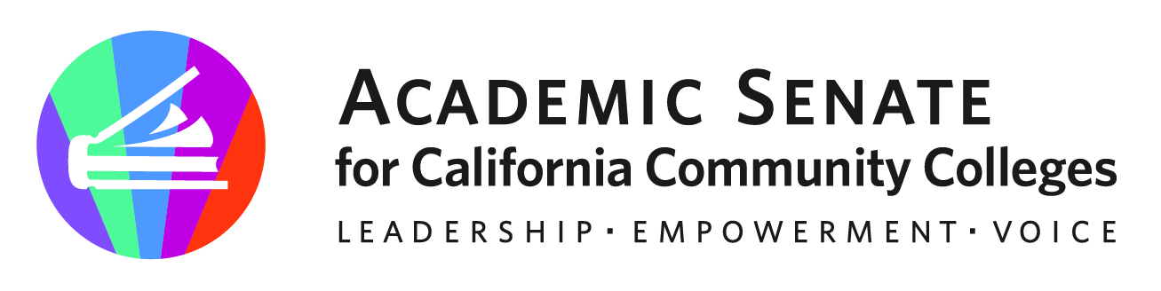

STANDARDS AND PRACTICES COMMITTEE

MINUTES

Topic: ASCCC Area D Representative's Standards and Practices Committee Zoom Meeting

Time: Sep 23, 2021 03:10 PM Pacific Time (US and Canada)

Join from PC, Mac, Linux, iOS or Android: https://cccconfer.zoom.us/j/95424574372

Or iPhone one-tap (US Toll): +16699006833, 95424574372# or +12532158782, 95424574372#

Or Telephone:

Dial:

+1 669 900 6833 (US Toll)

+1 253 215 8782 (US Toll)

+1 346 248 7799 (US Toll)

+1 646 876 9923 (US Toll)

+1 301 715 8592 (US Toll)

+1 312 626 6799 (US Toll)

Meeting ID: 954 2457 4372

International numbers available: https://cccconfer.zoom.us/u/aAJZ9KfOS

Or an H.323/SIP room system:

H.323: 162.255.37.11 (US West) or 162.255.36.11 (US East)

Meeting ID: 954 2457 4372

SIP: 95424574372@zoomcrc.com

Or Skype for Business (Lync):

SIP:95424574372@lync.zoom.us

- Meeting was called to order at 3:13p. The agenda was adopted (m/s Kirk/Ritt)
  - Attendance: Latonya Parker (chair); Karla Kirk (2nd Chair);Ed Bird Song; Eric Narveson, Miryan Nogueira; Travis Ritt

- Discussion of Application for Statewide Service: Link and information provided to committee

- Discussion of Assigned Resolutions (Fall Plenary) with request for any feedback to the Chair.
10.01 2021 Spring Disciplines List—Film and Media Studies
10.02 2021 Spring Disciplines List—Digital Fabrication Technology

  - Review and discussion of assigned tasks
2020-2021 End of Year Report Standards and Practices

Areas of potential focus for 2021-2022
- Review and evaluation of current ASCCC DEI implementations and strategies
- Awards handbook review-inclusivity updates, align handbook language with recently updated rubric language
- Review, evaluate and consider recommendations and/or Rostrum article based on the 2021 Center for Urban Education report for the ASCCC tited “Delivering on the Promise of Professional Development in California Community Colleges.
- Review charge in spring 2022
- Committee Priorities

- Plenary Planning
2021 Fall Plenary Session - Hybrid Event
Hybrid 2021 Fall Plenary Session on November 4-6, 2021 to be held at the Westin Long Beach in Long Beach, and via Pathable!
Theme: "Leading Change: Teaching, Learning, and Governance in a Hybrid World"

- Announcements
  - Upcoming Events and Meetings
•Executive Committee Meeting – Virtual – October 6, 2021
•2021 Academic Academy– Virtual Event – October 7- 8, 2021
•Area Meetings – October 15-16, 2021
•Executive Committee Meeting – Long Beach/Hybrid – November 3, 2021
•2021 Fall Plenary – Long Beach/Hybrid – November 4- 6, 2021

- Proposed Meeting Dates: Third Thursdays of the month
Thursday, October 21, 2021 3:10-4:10 pm
Thursday, November 18, 2021 3:10-4:10 pm
Thursday, December 9, 2021 3:10-4:10 pm

- Adjournment 4:07pm

